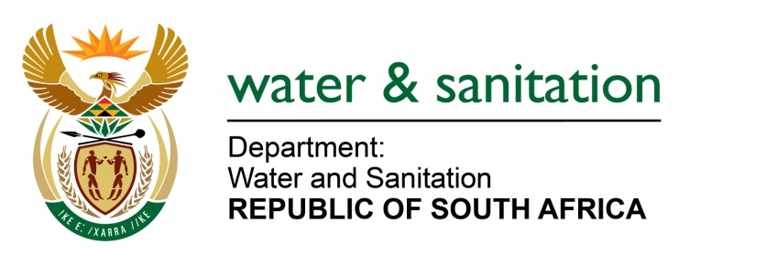

NATIONAL ASSEMBLY

FOR WRITTEN REPLY

QUESTION NO 694

DATE OF PUBLICATION IN INTERNAL QUESTION PAPER: 4 MARCH 2022
(INTERNAL QUESTION PAPER NO. 6)

694. Mr L J Basson (DA) to ask the Minister of Water and Sanitation:

(1) What steps does the Rand Water intend to take to resolve the electricity problems.

(2) Whether the Rand Water is looking at new ways of generating electricity; if not, why not; if so, what are the relevant details?

NW832E

---00O00---
MINISTER OF WATER AND SANITATION

(1) Rand Water consumes an average of 682 MWh a day of electricity for abstraction, treatment and distribution of water. Due to this requirement, Eskom and municipalities are the only electricity providers with distribution licences. A substantial portion of electricity is consumed at the treatment and booster stations.

Issues of planned and unplanned power outages are covered by the Electricity Supply Agreements between electricity suppliers and Rand Water as well as NERSA regulations. Rand Water ensures enforcement of the provisions in line with the contracts. In addition, Rand Water has undertaken a comprehensive risk assessment of its power suppliers and their infrastructure and is consulting Eskom with a view to understand their upgrade plans.

Rand Water has also embarked on projects to provide emergency power generators at its pumping stations. The project to provide these emergency power generators at six of tertiary pumping stations has been completed. The emergency power provision at the larger booster pumping stations is currently underway with anticipated completion by end 2023.

(2) Rand Water is embarking on the installation of Hydropower and Solar PV at some of its sites. However, it should be noted that even though this will provide additional electric energy, it will not be sufficient to supply treatment plants and booster stations due to the size of Mega Watts (MW) that will be generated as well as the geographical locations of installation. Innovative ways of generating electricity for Rand Water are still at very early stages and the entity continues to depend on Eskom for supply.
---00O00---

