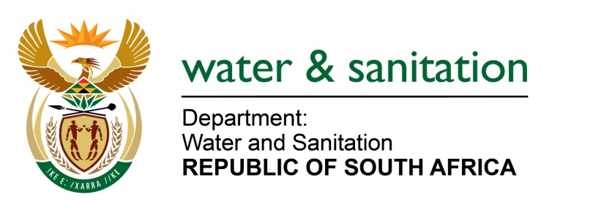

NATIONAL ASSEMBLY

FOR WRITTEN REPLY

QUESTION NO 693

DATE OF PUBLICATION IN INTERNAL QUESTION PAPER: 4 MARCH 2022
(INTERNAL QUESTION PAPER NO. 6)

693. Mr L J Basson (DA) to ask the Minister of Water and Sanitation:

What is the (a) total amount that her department was owing the water boards at the end of January 2018, (b)(i) name of each water board owed and (ii) amount outstanding in total in respect of each specified water board and (c) on what date is it envisaged that the amounts will be paid to the respective water boards?

NW831E

---00O00---

MINISTER OF WATER AND SANITATION

Name of the Water Boards | Period | Amount outstanding in total | On what date is it envisaged that the amounts will be paid to the respective water boards
Amatola Water | 2021/2022 | 6 914 022,59 | Amount will be settled by not later than the 25 March 2022.
Bloem Water | 2021/2022 | 1 536 436,37 | Amount will be settled by not later than the 25 March 2022.
Lepelle Northern Water | 2020/2021 | 13 290 001,62 | The amount will be settled by the 31 March 2022 after budget reprioritization.
Magalies Water |  | - | No outstanding invoices
Mhlathuze Water |  | - | No outstanding invoices
Overberg Water |  | - | No outstanding invoices
Rand Water | 2020/2021 | 132 211 798,20 | Amount of R1,4 million will be processed by not later than the 25 March 2022.The balance will settle after the budget reprioritization 31 March 2022.
Sedibeng Water |  | - | No outstanding invoices
Umgeni Water |  | - | No outstanding invoices
Total |  | 153 952 258,78

---00O00---

