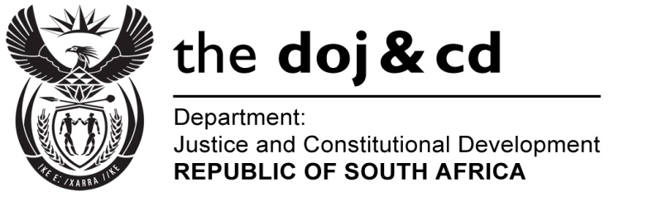
NATIONAL ASSEMBLY
QUESTION FOR WRITTEN REPLY
PARLIAMENTARY QUESTION NO: 693
DATE OF QUESTION: 17 MARCH 2017

DATE OF SUBMISSION: 03 APRIL 2017
Dr G A Grootboom (DA) to ask the Minister of Justice and Correctional Services:
- Did (a) his department or (b) any entity reporting to him participate in the Dialogue with the President: Unpacking of the SONA 2017 on Radical Economic Transformation Implementation event hosted at the Oyster Box Hotel in Umhlanga, Durban, on 25 February 2017; if so, what amount was spent in each case;
- did (a) his department or (b) any entity reporting to him participate in the auction of the (i) souvenirs or (ii) personal belongings of the President of the Republic, Mr Jacob G Zuma; if so, (aa) which items were purchased and (bb) at what cost, in each case?
NW752E
REPLY:

- Neither the Department of Justice and Constitutional Development (DoJ&CD) nor its entities (National Prosecuting Authority, Special Investigating Unit, the Office of the Chief Justice and Legal Aid South Africa) and the Department of Correctional Services (DCS) participated in the Dialogue with the President: Unpacking of the SONA 2017 on Radical Economic Transformation Implementation event hosted at the Oyster Box Hotel in Umhlanga, Durban, on 25 February 2017.
- Neither the Department of Justice and Constitutional Development (DoJ&CD) and the Department of Correctional Services (DCS) nor its entities participated in the auction of the souvenirs or personal belongings of the President of the Republic, Mr Jacob G Zuma.

