DEPARTMENT: PUBLIC ENTERPRISES
REPUBLIC OF SOUTH AFRICA

NATIONAL ASSEMBLY
QUESTION FOR WRITTEN REPLY
QUESTION NO.: 692

QUESTION:
692. Mrs M O Clarke (DA) to ask the Minister of Public Enterprises:
What (a) total number of incidents of fuel theft has Transnet had (i) in the 2019-20 financial year and (ii) since 1 April 2020, (b) was the total monetary value of the stolen fuel, (c) security measures have been put in place to prevent the incidents of fuel theft from reoccurring and (d) were the outcomes of law enforcement processes that unfolded to the incidents of fuel theft? NW810E

REPLY:
According to the information received from Transnet:
- (I) and (II): FUEL THEFT INCIDENTS 19/20 AND 20/21 FINANCIAL YEARS:
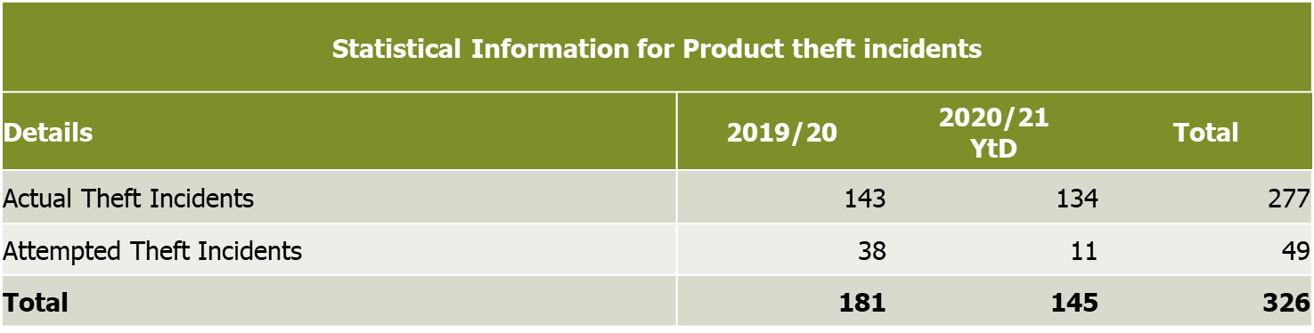

(b) TOTAL MONatETARY VALUE OF THE STOLEN FUEL:
The total monetary value of the stolen fuel is arrived at utilising the approximate volume lost at the Basic Fuel Price (BFP) plus taxes over the respective reporting date.
- 2019/20: R 147 m (11,9 million litres at R12,38 BFP & Tax)
- 2020/21: R 102 m (8,5 million litres at R12,03 BFP & Tax)
(C) security measures put in place:
Transnet has implemented various security measures which include tactical and aerial surveillance deployments. There is close collaboration with the Directorate for Priority Crime Investigation (“Hawks”), National Crime Intelligence and the National Prosecuting Authority (NPA) to deal with related fuel theft in the country.

Detail of Security Preventative Measures applied to reduce incidents:
- National Organised Crime Project registration (National Prosecuting Authority (NPA), Directorate Priority Crime Investigation (DPCI) and Crime Intelligence)
(II) Specialised Tactical Security deployments
- Specialised Aerial Surveillance deployments
- Specialised Aerial drone deployments
- Law Enforcement and TPL Security information/Intelligence led security operations
- National Law Enforcement engagements for interventions and support (SAPS, NatJoints and SANDF)
- Critical and Essential Infrastructure Protection Motivation – TPL Network (Pipeline) vs. only Pump Stations
- Establishment of Transnet Group Security Fusion Centre

In addition there are specific anti-intrusion systems that are in the process of being implemented along the pipeline system.
(D) OUTCOMES OF LAW ENFORCEMENT PROCESSES:
