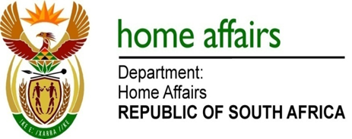

NATIONAL ASSEMBLY

QUESTION FOR WRITTEN REPLY

QUESTION NO. 691

DATE OF PUBLICATION: Friday, 17 March 2017

INTERNAL QUESTION PAPER 10 OF 2017

691. Mr H B Groenewald (DA) to ask the Minister of Home Affairs:

(1) Did (a) his department or (b) any entity reporting to him participate in the Dialogue with the President: Unpacking of the SONA 2017 on Radical Economic Transformation Implementation event hosted at the Oyster Box Hotel in Umhlanga, Durban, on 25 February 2017; if so, what amount was spent in each case;
(2) did (a) his department or (b) any entity reporting to him participate in the auction of the (i) souvenirs or (ii) personal belongings of the President of the Republic, Mr Jacob G Zuma; if so, (aa) which items were purchased and (bb) at what cost, in each case? NW750E
REPLY:
The question was forwarded to the Department and the entities who responded as follows:

Department of Home Affairs
(1)(a) No.
(2)(a) No.

Government Printing works
(1)(b) No.
(1)(b) No.

Electoral Commission
(1)(b) No.
(1)(b) No.

