DATE OF PUBLICATION OF INTERNAL QUESTION PAPER: 04/03/2022
INTERNAL QUESTION PAPER: O6/2022

686. Mrs D van der Walt (DA) to ask the Minister of Basic Education: to ask the Minister of Basic Education:

(1) (a) How is the equitable share calculation to provinces made and (b) what is the formula that is used for the portion allocated to public ordinary schools;
(2) whether there is an allocation to public special needs schools; if not, (a) why not and (b) how are the learners of such schools funded; if so, what is the formula that is used;
(3) whether there is an allocation for learners outside the compulsory school-going age of 7 to 15 years; if not, (a) why not and (b) how are such learners funded; if so, how is it calculated?

Response
Answer: 1(a): In terms of the equitable share, 48% of the overall budget should be allocated to Basic Education in the provinces but this is not always the case. The allocation of the budget (i.e. equitable share) in the provinces is the prerogative of the Provincial Executive.
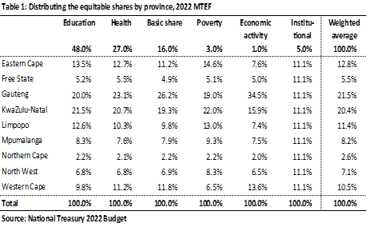
Answer 1(b): The Public Ordinary Schools’ operations are funded through the National Norms and Standards for School Funding (NNSSF). The NNSSF takes into account the quintile (Q) ranking of the schools which is pro poor with the poorest (Q1 to Q3) which are no fee schools receiving the highest subsidy.
Answer question 2: The Department of Basic Education (DBE) does not have policy relating to the funding of Special schools. The draft policy was not approved due to budget constraints. The DBE has developed Guidelines for Resourcing for Inclusive Education System in a quest to guide the PEDs whilst working towards a policy document in this regard.
Answer question 3: According to the National Treasury 2022 Budget, the equitable share formula for basic education is based on the age cohort 5 to 17 for school-going age and not 7 to 15. Table 2 is an example of the 2022 Budget. There is no earmarked or specific funding for learners above 17 years. The same allocation for the age cohort 5 to 17 is also extended to learners above 17 years.
