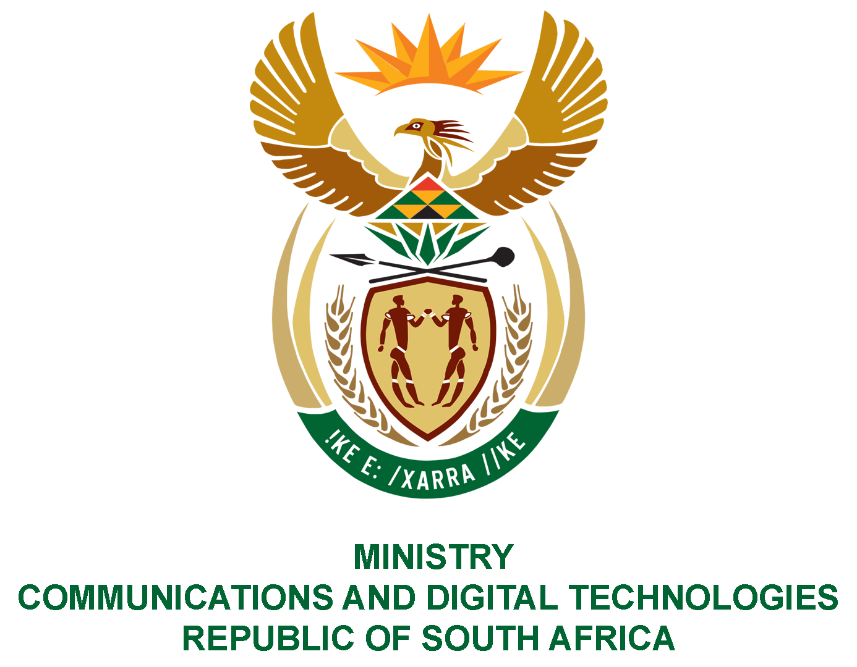

PARLIAMENT OF THE REPUBLIC OF SOUTH AFRICA
NATIONAL ASSEMBLY
WRITTEN REPLY

QUESTION NO: 686
DATE OF PUBLICATION: 24 April 2020
QUESTION PAPER NO: 12

Ms P T van Damme (DA) to ask the Minister of Communications:

(1) In respect of purchases made with each official credit card issued to (a) her, (b) her staff and (c) the Deputy Minister during the period 8 May 2014 up to the latest specified date for which information is available, (i) what is the (aa) name and (bb) organogram position of the user and (ii)(aa) what is the value of each purchase made, (bb) what are the details of each item purchased and (cc) for what purpose was each purchase made;

(2) whether any alcoholic beverages were purchased; if so, (a) what (i) are the relevant details and (ii) is the value of the specified purchases in each case and (b) for what purpose was each purchase made?
NW888E

REPLY:

- The Department did not issue any credit card issue to:

(a) Minister

- Ministry staff

- Deputy Minister

- (aa) N/A
(bb) N/A

- (aa) N/A
(bb) N/A
(cc) N/A

(2) (a) (i) N/A
(ii) N/A

(b) N/A

MR J MTHEMBU, MP
ACTING MINISTER OF COMMUNICATIONS AND DIGITAL TECHNOLOGIES

