MINISTER OF TOURISM
REPUBLIC OF SOUTH AFRICA

Private Bag X424, Pretoria, 0001, South Africa. Tel. (+27 12) 444 6780, Fax (+27 12) 444 7027
Private Bag X9154, Cape Town, 8000, South Africa. Tel. (+27 21) 469 5800, Fax: (+27 21) 465 3216

NATIONAL ASSEMBLY:

QUESTION FOR WRITTEN REPLY:
Question Number: 686
Date of Publication: 30 August 2019
NA IQP Number: 12
Date of reply: 28 October 2019

Ms H Ismail (DA) to ask the Minister of Tourism:

(a) How does the Tourism Indaba perform in comparison to other Indabas both locally and internationally, (b) what were the costs of the Tourism Indaba in the past three financial years, (c) how are the returns to the tourism sector calculated and (d) what were the returns derived from the Tourism Indaba for the past three financial years? NW1728E

Reply:

- How does the Tourism Indaba perform in comparison to other Indabas both locally and internationally?

The tourism trade show landscape is categorised as either a business or leisure trade show. Within the arena, there are International, regional /continental and national shows. Indaba is uniquely positioned as the premium leisure tourism show on the African continent, which is purely inbound, with the exception of some African products. While the exhibitor mix for each show is specific to the scale and individual show positioning, the buyer and media pool remains finite globally, as these are trade specific. Indaba as a platform is a mandate-driven entity, and is not commercially driven.
Other international tourism trade shows are far larger in size, rendering a skewed direct comparison as these shows showcase a full spectrum of global products across numerous countries. They feature both inbound and outbound whereas Indaba centres only on inbound. In drawing a comparison to similar shows, the following insights have been gathered against potential direct competitors, given that even these shows operate differently.
Hereto, Indaba has long-standing equity being a home-grown show that is inbound-focussed, and geared purely towards the growth of the exhibitors and is the only continental leisure show that is not commercially driven.
Due to its scale it still largely remains the biggest tourism trade show on the continent, compared to WTM Africa, We Are Africa (WAA) and Magical Kenya (MKTE). The scale is attributed to the number of exhibitors, buyers and media in attendance. Indaba has also demonstrated a strong imperative of transformation with an annual increase in SMME product participation. Floor-space rates are considerably cheaper than MKTE and WAA. WTM Africa rates are not published.
The primary success factors of Indaba remain the continued and loyal exhibitor base, the quality of buyers (hosted and non-hosted) based on the stringent qualification and selection process, and the number of meetings that are facilitated by means of a sophisticated online diary and matchmaking system.

- What were the costs of the Tourism Indaba in the past three financial years?

High-Level Income and Expenditure
 | 2017 | 2018 | 2019
Income | R41 327 796.00 | R37 137 525.91 | R 40 345 665,70
Expenditure* | R102 880 417.04 | R47 989 450.14 | R51 000 357.38
Surplus/Deficit | -R61 552 621.04 | -R10 851 924.23 | -R10 654 691.68
- Includes Pre & Post Show Tours that leverage the Indaba platform to market destination to hosted buyers and media
- Expenditure includes Exhibition Management, Events, Activation, Branding, Pre/Post Show Tours & Hosted Buyer, Hosted Media, Staff and Supplier Travel to Durban (return)
- Costs for Pre & Post Show Tours are held by independent country budgets

**2019 Revenue currently unavailable as audit is underway; due end October 2019

The objective of Africa’s Travel Indaba in line with SA Tourism’s mandate is to create a platform for South African Tourism and the industry/exhibitors to meet and formulate sound business opportunities with local and international buyers. Therefore, Africa’s Travel Indaba is not aimed to be a revenue driven tradeshow, the business model is to offset the production costs with the revenue collected from exhibitors, to minimise the costs for South African Tourism. By doing so SAT support SMME’s ( Hidden Gems)

- How are the returns to the tourism sector calculated?
CALCULATION: RETURN ON INVESTMENT(ROI) NOTIONAL (Quantitative)
Using overall averages of reported investment and transactions to calculate ROI for exhibitors. Calculation is derived from Average financial gain vs average financial investment of exhibitors.
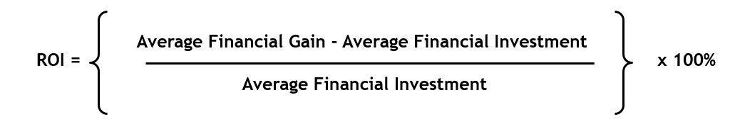

- What were the returns derived from the Tourism Indaba for the past three financial years?

The returns to the tourism sector / participants to the show are quantified, in respect of the meetings that are conducted at the platform, 2018 was the first time that the study was undertaken, and a similar methodology for 2019 which is currently underway, is being applied.
For 2018, and in respect of the above-stated ROI Calculation, please find ROI for Indaba 2018, detailing average financial gain vs average financial investment of exhibitors:

