DATE OF PUBLICATION OF INTERNAL QUESTION PAPER: 04/03/2022
INTERNAL QUESTION PAPER: 06/2022

685. Mrs D van der Walt (DA) to ask the Minister of Basic Education: to ask the Minister of Basic Education:

What is the total number of (a) single-medium schools of each language in the Republic, (b) schools for each language in each province and (c) single-medium schools that were closed in each province in the (i) 2020-21 and (ii) 2021-22 financial years and (ii) what were the reasons for each closure?

Response
Response: (a) (b)

Table 1 indicates that, there were 7 106 single medium schools in the country. Majority of these schools were English medium with 5 964 schools.

Number of Single Medium Schools per Province, in 2021
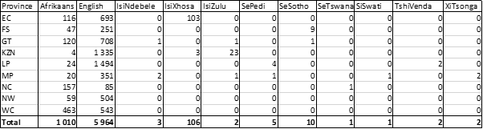
Source: LURITS 2021
(c) (i) During the 2020/21 and 2021/22 financial years there were eight (8) single medium schools that were closed and these schools were from Mpumalanga.

(ii) Reasons for closure: There are various measures that can lead to merger or closure of schools. The Department of Basic of Education has provided Provincial Education Departments with Guidelines for Rationalisation and Re-alignment of Public Schools; Holistic Approach. The primary objective of the School Rationalisation process is to continue providing universal access to quality basic education in a rational manner, doing so cost effectively with respect to resource provisioning, where the costs being referred to are not only limited to monetary costs but also socio-economic imperatives.

