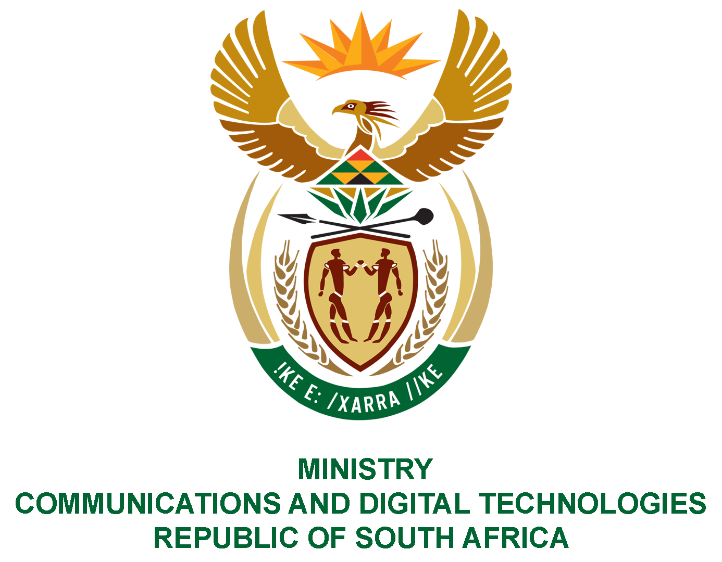

PARLIAMENT OF THE REPUBLIC OF SOUTH AFRICA
NATIONAL ASSEMBLY
WRITTEN REPLY

QUESTION NO: 685
DATE OF PUBLICATION: 24 April 2020
QUESTION PAPER NO: 12

Ms P T van Damme (DA) to ask the Minister of Communications:

(1) What are the relevant details of official credit cards issued to (a) her, (b) her staff and (c) the Deputy Minister;

(2) In respect of each specified credit card, (a) what is the (i) name and (ii) organogram position of the user, (b) what is the (i) maximum permissible value of each purchase and (ii) total credit limit of the card, (c) what are the relevant details of permissible purchases for which each credit card may be used and (d) may alcoholic beverages be purchased?
NW887E

REPLY:

- The Department did not issue any credit card issue to:

(a) Minister

- Ministry Staff

- Deputy Minister

(2) (a) (i) N/A
(ii) N/A

(b) (i) N/A
(ii) N/A

(c) N/A

(d) N/A

MR J MTHEMBU, MP
ACTING MINISTER OF COMMUNICATIONS AND DIGITAL TECHNOLOGIES

