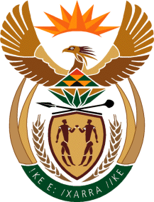

MINISTER IN THE PRESIDENCY: REPUBLIC OF SOUTH AFRICA
Private Bag X1000, Pretoria, 0001, Union Buildings, Government Avenue, PRETORIA
Tel: (012) 300 5200, Website: www.thepresidency.gov.za

NATIONAL ASSEMBLY
WRITTEN QUESTION FOR WRITTEN REPLY

QUESTION NUMBER: 679
DATE OF PUBLICATIONS: 5 March 2021

679. Mr L J Basson (DA) to ask the Minister in The Presidency:

Whether (a) her Office and/or (b) any entity reporting to her makes use of private security firms; if not, what is the position in this regard; if so, in each case, what is the (i) name of each firm, (ii) purpose, (iii) value and (iv) duration of each specified contract? NW797E

REPLY:
- None of the two Entities (Brand SA and MDDA) use private security.

Thank you.

