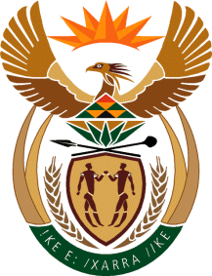

MINISTRY OF TOURISM
REPUBLIC OF SOUTH AFRICA

Private Bag X424, Pretoria, 0001, South Africa. Tel. (+27 12) 444 6780, Fax (+27 12) 444 7027
Private Bag X9154, Cape Town, 8000, South Africa. Tel. (+27 21) 469 5800, Fax: (+27 21) 465 3216

NATIONAL ASSEMBLY:

QUESTION FOR WRITTEN REPLY:
Question Number: 675
Date of Publication: 30 August 2019
NA IQP Number: 12
Date of reply: 19 September 2019

Mr G R Krumbock (DA) to ask the Minister of Tourism:
Whether any studies have been conducted to determine the impact of the Government’s proposed National Health Insurance system on health and medical tourism in the Republic; if not, why not; if so, what has the study found will be the likely (a) decline in international arrivals of so-called health and medical tourists once the National Health Insurance is implemented, (b) decline in tourism revenue generated from health and medical tourists and (c) total impact on the Republic’s fiscus? NW1717E

Reply:
No studies have been conducted by the department of Tourism or its entity (South Africa Tourism) to determine the impact of the Government’s proposed National Health Insurance system on health and medical tourism in the Republic as the system has not been finalised yet.

- Not applicable
- Not applicable
- Not applicable

