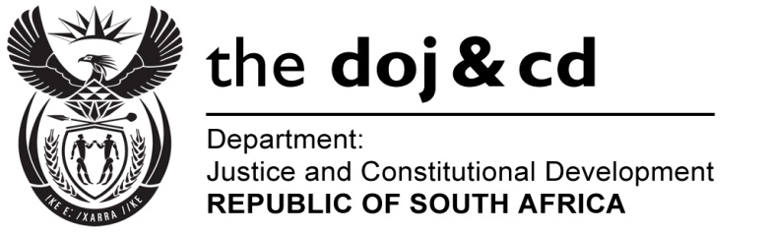
NATIONAL ASSEMBLY
QUESTION FOR WRITTEN REPLY
PARLIAMENTARY QUESTION NO: 667

DATE OF SUBMISSION: 17 MARCH 2017

DATE OF SUBMISSION: 31 MARCH 2017
Ms T E Baker (DA) to ask the Minister of Justice and Correctional Services:

With reference to the Minister of Police’s replies to (a) question 3723 on 2 November 2015, (b) question 62 on 29 February 2016 and (c) oral question 98 on 25 May 2016, (i) what is the current status of the National Prosecuting Authority’s investigation into docket CAS 123/03/2014, opened at the Nkandla Police Station regarding eight charges of corruption against the President, Mr Jacob G Zuma, in terms of the Prevention and Combatting of Corrupt Activities Act, Act 12 of 2004, for his alleged complicity in the alleged misappropriation of public funds to upgrade his personal residence at Nkandla, (ii) which unit is the specified investigation currently with, (iii) what are the names of the persons that have been questioned to date and (iv) by what date is it to be expected that the specified investigation will be finalized?
NW726E

REPLY:

- The matter which was investigated by SAPS is still under consideration by the National Prosecuting Authority.
- The matter is under consideration of the Priority Crimes Litigation Unit (PCLU) of the NPA.
- The names of potential witnesses and persons who have been questioned during the course and scope of this ongoing investigation cannot be disclosed.
- It is regrettably not possible to provide a definitive date on which this investigation is expected to be concluded.
r (a) Ms Nomgcobo Jiba and (b) Mr Lawrence Mrwebi resumed their duties at the National Prosecuting Authority (NPA); if so, (i) on what date did the specified persons resume their duties at the NPA and (ii) what course of action has he advised the President of the Republic, Mr Jacob G Zuma, to take in each case? (a) what amount was spent on hotel accommodation for the specified person since his appointment and (b) who is responsible for the coists of the accommodation? NW6NW694E
REPLY:

