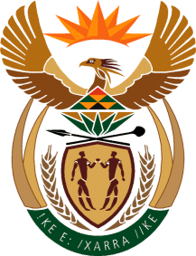

MINISTRY OF TOURISM
REPUBLIC OF SOUTH AFRICA

Private Bag X424, Pretoria, 0001, South Africa. Tel. (+27 12) 444 6780, Fax (+27 12) 444 7027
Private Bag X9154, Cape Town, 8000, South Africa. Tel. (+27 21) 469 5800, Fax: (+27 21) 465 3216

NATIONAL ASSEMBLY:

QUESTION FOR WRITTEN REPLY:
Question Number: 663
Date of Publication: 3 March 2023
NA IQP Number: 6
Date of reply:

Ms R N Komane (EFF) to ask the Minister of Tourism:

(1) What reasons has she found lie behind the delays in configuring the process between Brand SA and Tourism SA;

(2) whether both Ministries and boards have met to engage on the proposed merger; if not, why not; if so, how long will the engagements take? NW735E

REPLY:
(1) and (2)

I have discussed the matter with the Minister in the Presidency responsible for BrandSA.

It appears that there was no Cabinet decision on the matter as it had never served in Cabinet.

Furthermore, consultations with affected and interested parties had not been concluded.

