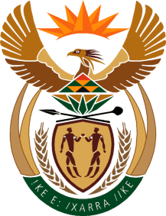

MINISTRY OF TOURISM
REPUBLIC OF SOUTH AFRICA

Private Bag X424, Pretoria, 0001, South Africa. Tel. (+27 12) 444 6780, Fax (+27 12) 444 7027
Private Bag X9154, Cape Town, 8000, South Africa. Tel. (+27 21) 469 5800, Fax: (+27 21) 465 3216

NATIONAL ASSEMBLY:

QUESTION FOR WRITTEN REPLY:
Question Number: 662
Date of Publication: 3 March 2023
NA IQP Number: 6
Date of reply:

Mr A Matumba (EFF) to ask the Minister of Tourism:

(a) What process was followed in the appointment of three members of the board of Tourism SA to replace the members who resigned and (b) on what date will the process of appointing board members in accordance with section 16(2) in line with section 13(3) and (4) of the Tourism Act, Act 3 of 2014, be undertaken? NW734E
REPLY:

I did not receive a handover on which processes were followed in appointing the three Board members by my predecessor.
On Friday 18 April, via a Government Gazette, I will dissolve the SA Tourism Board.

In the same Gazette, I will appoint three Interim Board members in terms of Section 16 (3) (b) of the Tourism Act with experience in Finance, Governance and Tourism.

These three members will have full decision-making powers until such time that the Board is officially appointed.

