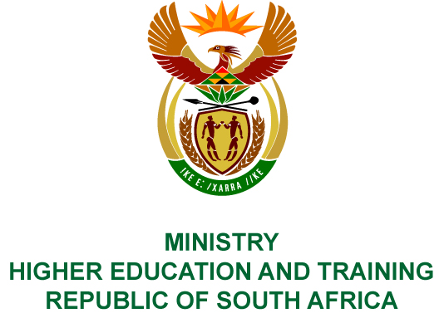
Private Bag X893, Pretoria, 0001, Tel: 012 312 5555, Fax: 012 323 5618
Private Bag X9192, Cape Town, 8000, Tel: 021 469 5150, Fax: 021 465 7956
MEMORANDUM FROM THE PARLIAMENTARY OFFICE
NATIONAL ASSEMBLY
FOR WRITTEN REPLY
QUESTION 661
DATE OF PUBLICATION OF INTERNAL QUESTION PAPER: 15/03/2019
INTERNAL QUESTION PAPER NO 08 OF 2019
Mr M G P Lekota (Cope) to ask the Minister of Higher Education and Training:
What (a) is the extent of fraud and corruption that has been uncovered and (b) is being done about the uncovered corruption with regard to the National Student Financial Aid Scheme?
NW784E

REPLY
- The National Student Financial Aid Scheme (NSFAS) has appointed forensic investigators and investigations are currently underway.
- Appropriate action will be taken once the investigations have been completed.

