PRIVATE BAG x 59, PRETORIA, 0001, Tel (012) 444 3979, Fax (012) 444 3145
PRIVATE BAG x 9111, CAPE TOWN, 8000 (021) 462 23J0, Fax (021) 461 0859
Enquiries: Carmichael Ngalo G› Carmichael. ngaloodmr.gov.za

Memorandum: Parliamentary Liaison Dffice
NATIONAL ASSEMBLY QUESTION FOR ORAL REPLY

QUESTION NUMBER: 66 ADVANCE NOTICE No: NW 1023E

DATE OF PUBLICATION IN INTERNAL QUESTION PAPER: 20 June 2019 INTERNAL QUESTION PAPER NUMBER: 01

A44. Mr D F Mthenjane (EFF) to ask the Minister of Mineral Resources and Energy:
Whether the Republic has any rare earth mineral resources; if so, (a) what is the
(i) location, (ii) value and (iii) quantity of the rare earth minerals and (b) which companies are currently extracting the rare earth minerals in each case?

NW1023E

Reply

- The Republic has rare earth mineral resources (i) Found in the Western Cape Province on the farms, Steenkampskraal and Zanddrift, while surrounding farms are being explored for them (ii) the value of the resources is not known (iii) At the Steenkampskraal mine, the quantity is estimated at 605,000 tons at an average grade of 14.36 percent and total rare earth content of 86, 900. tons but, it is not known for Zanddrift.

- None

Miner Policy Promotion
: Ms Nt kozo Ngcwabe Date: @@

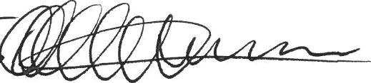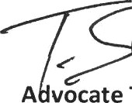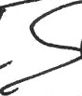Recommended /

A vocate T Mokoena

Director General: Department of Mineral Resources

. ....../.... ..../2019

Approved

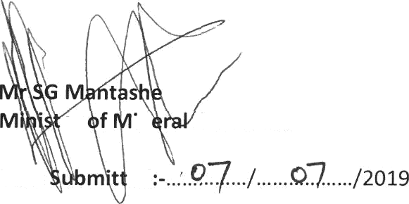
er
in
Resources
Date
ed

