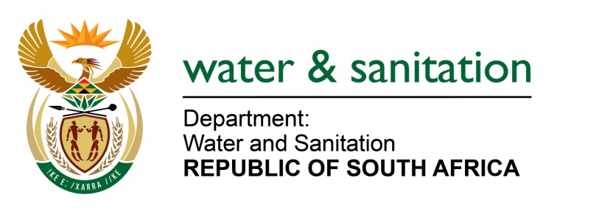

NATIONAL ASSEMBLY

FOR WRITTEN REPLY

QUESTION NO 659

DATE OF PUBLICATION IN INTERNAL QUESTION PAPER: 03 MARCH 2023
(INTERNAL QUESTION PAPER NO. 6)

659. Mrs M R Mohlala (EFF) to ask the Minister of Water and Sanitation:
What (a) steps has his department taken to (i) reduce the effects of climate change and global warming on water scarcity and (ii) intervene to stop the increase of water pollution and (b) are the further relevant details of steps taken in this regard? NW731E
---00O00---

MINISTER OF WATER AND SANITATION

- The department is mainstreaming climate change and response into planning (project design), implementation, and management of water resources. The implementation of climate risk assessment and management is done through systematically assessing, addressing, and adaptively managing climate risks in new strategies, projects, and activities, thus facilitating climate resilience to both prevailing and projected future climates. This is guided by the Water and Sanitation Sector Policy which sets out principles that strive to strengthen the effective protection, conservation, and management of water resources against the impacts of climate change.

Further, the Department has and is continuously mainstreaming climate change risk and vulnerabilities, and climate responses (adaptation) into its strategies and operations such as Climate Change Response Strategy, National Water Resource Strategy-3, among others. The Department is in its final stages of updating its climate change strategy for the water and sanitation sector, this will ensure that the adaptation and responses (including updating of risk and vulnerability assessments) developed are informed by the latest and refined Global Climate Models.
- The department is responsible for the development and implementation of legislation and regulatory tools to ensure that water resources are protected.
The National Water Act 36 of 1998, requires water use activities emanating from water users to be authorised. The authorization conditions imposed to users involve ensuring that negative impacts of such activities on water resources are assessed, prevented or minimised.

The quality of the water resources is also monitored through various national and regional monitoring programs to determine the status of our water resources and to ensure pollution is identified and mitigated timeously.

Compliance to the above regulatory conditions is monitored and enforced through the National Water Act 36 of 1998. During the 2021/2022 financial year, 182 pollution cases were reported to the Department which translated to 142 administrative enforcement actions and 3 criminal cases referred to the National Prosecuting Authority (NPA). A total of 40 cases were closed as they had complied with legislative requirements.

In November 2019, the Department formally established the Anti-Pollution Task Team (APTT), with the aim of identifying and assessing risks that can cause pollution in water resources and finding remedies to mitigate pollution impacts on water. Some of the key tasks of the APTT are:

- development and implementation of anti-pollution management protocols and interface with other institutions (such as law enforcement agents) to ensure that polluters are brought to book,
- monitoring and implementation of the Integrated Water Quality Management Strategy (IWQMS) of 2017, which sets out strategic actions that are required to be undertaken to realise the vision and goals of water quality in South Africa,
- support and monitoring of the implementation of existing departmental functions dealing with pollution matters and improving water quality.

With support and interface with other law enforcement agencies, the department continues to implement enforcement action against polluters to ensure our water resources are protected.

(b) Other relevant steps taken by the department in these regards include:

- Continuous research in collaboration with the Water Research Commission (WRC)
- Sustainable Development Goals (SDG) monitoring and comparative analysis programs
- Participation in international water related events like the World Water Week in Stockholm and the International Commission on Large Dams (ICOLD) conferences

The aim of taking these steps is to ensure that the department has good exposure to relevant and new technologies and innovations for water resources management in general.
---00O00---

