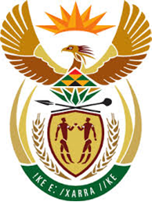

DEPARTMENT: PUBLIC ENTERPRISES
REPUBLIC OF SOUTH AFRICA

NATIONAL ASSEMBLY
659. Dr P J Groenewald (FF Plus) to ask the Minister of Public Enterprises:†
(1) Whether SA Airways has provided any guarantee in the (a) 2016-17, (b) 2017-18 and (c) 2018-19 financial years; if so, (i) to whom were these guarantees given, (ii) for which (aa) amount and (bb) term in each case and (iii) what was the activity in each case in each specified financial year;
(2) what was the justification for the sponsorship in each case in each specified financial year;
(3) whether he will make a statement on the matter? NW782E

Reply:
The Parliamentary question has been forward to South African Airways and the Department and the Ministry of Public Enterprises awaits their response. Further information will be conveyed to Parliament as soon as the response is received.

