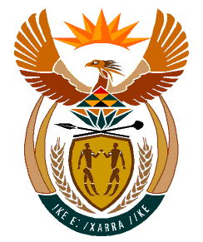

MINISTRY:
HUMAN SETTLEMENTS, WATER AND SANITATION
REPUBLIC OF SOUTH AFRICA

NATIONAL ASSEMBLY

QUESTION FOR WRITTEN REPLY

QUESTION NO.: 653

DATE OF PUBLICATION: 24 APRIL 2020

Ms B M van Minnen (DA) to ask the Minister of Human Settlements, Water and Sanitation:
(a) Who are currently the SA Delegates to the Lesotho Highlands Water Commission, (b) what number of vacancies exist in the Commission, (c) what has been the period for which these vacancies existed and (d) what steps has she taken to fill the vacancies? NW855E

REPLY:
(a) The posts occupied by South Africa’s Delegation to the Lesotho Highlands Water Commission are as follows:

- Chief Delegate, in an acting capacity
- Permanent Representative
- Delegate: Executive for Project Management and Implementation
- Three Alternate Delegates

Unfortunately, I am constrained and prohibited by the document titled “Guide to Parliamentary Questions in the National Assembly” from providing the Honourable Member with the names of the SA Delegates to the Lesotho Highlands Water Commission. The document referred to states that:
“Questions are to be framed as concisely as possible. All unnecessary adjectives, references and quotations are omitted. Names of persons, bodies and, for example, newspapers are only used in questions if the facts surrounding the case have been proven. As the mere mention of such names could be construed as publicity for or against them, it should be clear that this practice is highly undesirable. If a question will be unintelligible without mentioning such names, the Departments concerned are notified of the name (-s) and this phrase is used: ".......a certain person (name furnished)”

(b) The post of the Chief Delegate in the Commission is vacant.

(c) The Chief Delegate’s post has been vacant since 19 May 2019.

(d) The vacant post was advertised on 12 January 2020 and the process of filling the post is well underway.

