NATIONAL ASSEMBLY
36/1/4/1(201900084)

FOR WRITTEN REPLY

QUESTION 653

DATE OF PUBLICATION IN INTERNAL QUESTION PAPER: 15 MARCH 2019 (INTERNAL QUESTION PAPER NO 8-2019)

653. Mr S P Mhlongo (EFF) to ask the Minister of Police:

What number of firearms is held by each security company registered with the Private Security Industry Regulatory Authority at a (a) provincial level and (b) national level?
NW761E
REPLY:

- A total of 2 677 security companies are registered with the Private Security Industry Regulatory Authority (PSIRA), with 102 943 firearms registered on the Central Firearm Register (CFR) database.

Province | Number of Security Companies | Number of Firearms
Eastern Cape  Free State | 168 | 2 823
 | 50 | 517
Gauteng  KwaZulu-Natal | 909  499 | 64 305  17 676
Limpopo | 649 | 11 172
Mpumalanga | 126 | 2 193
North West | 93 | 1 607
Northern Cape | 20 | 135
Western Cape | 163 | 2 515
Total | 2 677 | 102 943
- There are no security companies registered at a national level.

2

Reply to question 653 recommended/

TI L C
OLE (SOEG)

Date: ygjj .gj. gy
GENERAL H AFRICAN POLICE SERVICE

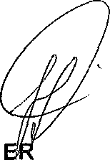
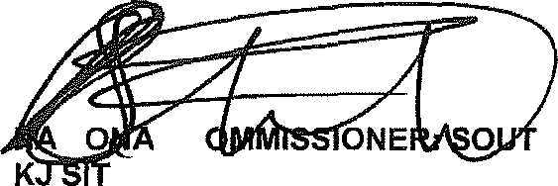
Reply to question 653 approved/natapprove&

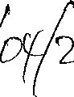
MINIST OF POLICE BH CELE, MP
Date.' D

