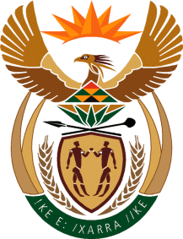

MINISTRY OF TOURISM
REPUBLIC OF SOUTH AFRICA

Private Bag X424, Pretoria, 0001, South Africa. Tel. (+27 12) 444 6780, Fax (+27 12) 444 7027
Private Bag X9154, Cape Town, 8000, South Africa. Tel. (+27 21) 469 5800, Fax: (+27 21) 465 3216

NATIONAL ASSEMBLY:

QUESTION FOR WRITTEN REPLY:
Question Number: 652
Date of Publication: 5 March 2021
NA IQP Number: 6
Date of reply: 21 April 2021

Mr H S Gumbi (DA) to ask the Minister of Tourism:
(1) Whether she has any structured ongoing engagement with community tourism organisations (CTO); if not, why not; if so, what are the relevant details;
(2) what (a) proportion of CTOs has she and/or her department found to be effectively operational in each province and (b) are the criteria that determines this;
(3) (a) what is the last date that she had a structured engagement with CTOs, (b)(i) where and (ii) how did this take place, (iii) who were the participants in this engagement and (iv) what was the basis of the discussion?
NW770E

REPLY:

- The Minister of Tourism undertakes tourism stakeholder outreaches across the country, wherein she engages with various stakeholders within local communities. Thus, the Minister takes an inclusive approach at a community level with participation by all affected and interested parties.

- (a) and (b) Neither the Department of Tourism nor the Minister of Tourism have mandate to evaluate functionality of Community Tourism Organisations or any other tourism association as these are voluntary associations.

- (a)(i) and (b)(i) and (ii) The latest engagement was in the Northern Cape in the areas of Upington and Rimvesmark in a form of Ministerial outreach linked to the tourism recovery efforts and revitalisation of domestic tourism in particular.
(iii)The engagements were attended by amongst others the provincial government, local government, and local tourism business community.
(iv)To obtain insights into the key tourism issues and opportunities for improvements where necessary.

