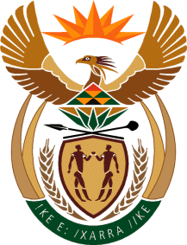

MINISTRY OF TOURISM
REPUBLIC OF SOUTH AFRICA

Private Bag X424, Pretoria, 0001, South Africa. Tel. (+27 12) 444 6780, Fax (+27 12) 444 7027
Private Bag X9154, Cape Town, 8000, South Africa. Tel. (+27 21) 469 5800, Fax: (+27 21) 465 3216

NATIONAL ASSEMBLY:

QUESTION FOR WRITTEN REPLY:
Question Number: 651
Date of Publication: 5 March 2021
NA IQP Number: 6
Date of reply: 21 April 2021

Mr H S Gumbi (DA) to ask the Minister of Tourism:
(1) Whether there are any public funds that are used towards the management of community tourism organisations (CTOs); if not, what is the position in this regard; if so, what (a) amount and (b) are the relevant details;
(2) whether there are any public funds that are transferred to CTOs, if not, what is the position in this regard; if so, (a) what amount, (b) how is the amount determined for each CTO and (c) which department and/or entity provides the funds? NW769E

REPLY
- and (2) Community Tourism Organisations (CTOs) are independent associations based on voluntary participation by their membership. The organisations are responsible for their operations including financial aspects thereof. The Department of Tourism does not fund CTOs.

