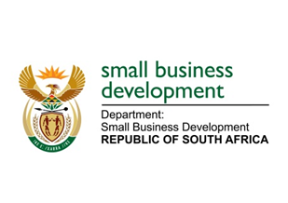
NATIONAL ASSEMBLY

QUESTION FOR WRITTEN REPLY

65. Adv T E Mulaudzi (EFF) to ask the Minister of Small Business Development:
(1) Whether she has been informed that she has been implicated in testimony made under oath and in written documents by Mr Agrizzi at the Judicial Commission of Inquiry to Inquire into Allegations of State Capture, Corruption and Fraud in the Public Sector including Organs of State, chaired by Deputy Chief Justice Raymond Zondo; if so, were the allegations made by Mr Agrizzi in respect of her true;
(2) whether she declared any financial or material gifts from Bosasa as required by the Executive Members’ Ethics Act, Act 82 of 1998; if not, what is the position in this regard; if so, what are the relevant details?
NW70E
REPLY:

- The Minister has not been informed that she has been impacted in the above. The Minister is also not aware of any allegations made against her by Mr Agrizzi as indicated above with regards to the said Commission.

- All gifts are recorded accordingly in the gifts register and submitted in line with the Executive Members’ Ethics Act 83 of 1998, none such were received from Bosasa.

