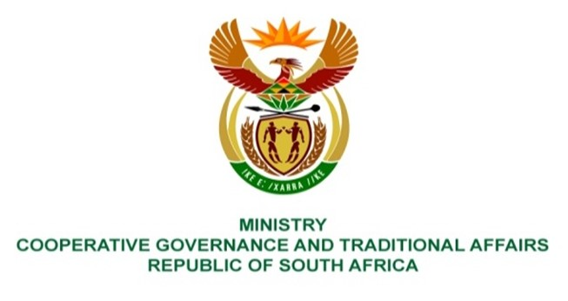

NATIONAL ASSEMBLY
QUESTIONS FOR WRITTEN REPLY

QUESTION NUMBER 648
648. Mrs L F Tito (EFF) to ask the Minister of Cooperative Governance and Traditional Affairs:
Whether her department is responsible for fixing the houses and properties in Ward 7 and Ward 17 in the Sol Plaatje Local Municipality in Kimberley which were damaged during the flooding of dams, during the 2020-21 financial year; if not, what is the position in this regard; if so, when will it be fixed? NW720E
Reply:
Fixing homes and properties is not the Department of Coorperative Governance and Traditional Affairs' responsibility. The Department of Human Settlements is responsible for this. It is advised that the Ministry of Human Settlements receive the inquiry.
End.

