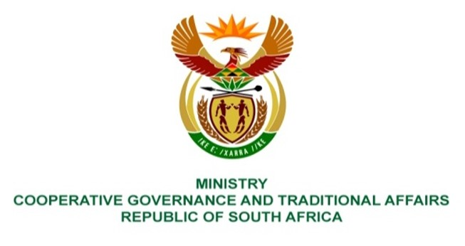

NATIONAL ASSEMBLY
QUESTIONS FOR WRITTEN REPLY

QUESTION NUMBER: PQ2022/648
DATE OF PUBLICATION: 4/3/2022

QUESTION:

Mr C Brink (DA) to ask the Minister of Cooperative Governance and Traditional Affairs:
(1) Whether (a) she and/or (b) her department have made any submissions to the High Level Task Team on the Framework towards the Professionalisation of the Public Service that was appointed by the Minister of Public Service and Administration in May 2021; if not, what is the position in this regard; if so, will she furnish Mr C Brink with a copy, record and/or summary of the submissions;
(2) whether she has found that the local government sector has been sufficiently represented in the process of producing a final version of the Framework to date; if not, why not; if so, what are the relevant details? NW786E

REPLY:

- (a) and (b) Yes. The Department was consulted on the development of a framework aimed at professionalising the public service and its inputs were shared with the Department of Public Service and Administration. A copy of the submission is annexured hereto.

- Apart from participating in various processes during the development of the said framework, the Department recently promulgated the Municipal Staff Regulations setting out uniform standards and procedures governing career incidents of municipal staff below management echelon. The Regulations were consulted with the Minister of Public Service and Administration whose valuable inputs were received and incorporated into the Regulations.

BACKGROUND:

1. Government in its transformation role of enuring that South Africa becomes a truly nonracial and democratic country, it continues to be grappling with developmental challenges. To respond to these challenges, in 2012, government adopted the National Development Plan (NDP) Vision 2030 as a long-term strategic goal to address the triple challenges of reducing poverty, inequality and unemployment. In the context of the role of the state, Chapter 13 of the NDP envisions South Africa as a Capable and Developmental State. The NDP further makes an assertion that the state needs to play a transformative and developmental role. Accordingly, this requires a well-run and effectively coordinated state institutions with skilled public servants who are committed to the public good and capable of delivering consistently high quality services, while prioritising the nation’s developmental objectives.

- To realise the above mentioned NDP 2030 vision, in 2018, the Public Service Commission conducted a roundtable discussion on the professionalisation of the pubic service. The roundtable recommended that the implemnentaion of key recommendations in Chapter 13 of the NDP need to be fasttracked, led by Office of the President. These include the creation of the Administrative Head of the Public Service and a strengtherned role for the Public Service Commission. It further recommended that the DPSA should be the champion of the project to professionalise the Public Service.

- Emanating from the above, the Minister for the Public Service and Administration approved the publication of the draft National Implementation Framework towards the Professionalisation of the Public Service for public comments. The Framework recommends among other provisions, that the public service be merit-based and insulated from party politics. Five critical professionalisation pillars are proposed, namely;

- Pre-entry recruitment and selection within the public service
- Induction and onboarding
- Planning and performance management
- Continuous learning and professional development
- Career progression and management of career incidence

- A number of stakeholders, including government departments, professional bodies, civil society organisations etc were invited to participate and make written submissions during the consultation process.

