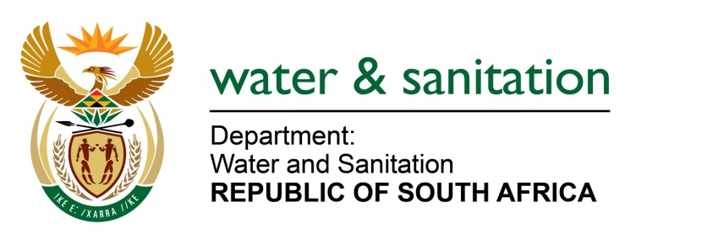

NATIONAL ASSEMBLY

FOR WRITTEN REPLY

QUESTION NO 647

DATE OF PUBLICATION IN INTERNAL QUESTION PAPER: 03 MARCH 2023
(INTERNAL QUESTION PAPER NO. 6)

647. Mr K Ceza (EFF) to ask the Minister of Water and Sanitation:
Whether he has instituted any investigation into allegations of fraud and maladministration by officials in his department’s finance division in relation to water allocation and use that is reserved for blacks for their own farming operations in Groot-Marico, and that a certain person (name furnished) has been using the water for his own farming operations; if not, why not; if so, what are the relevant details?
NW719E
---00O00---

MINISTER OF WATER AND SANITATION

The Department of Water and Sanitation is aware of the allegations and referred the matter to the Internal Audit Unit for investigation.

---00O00---

