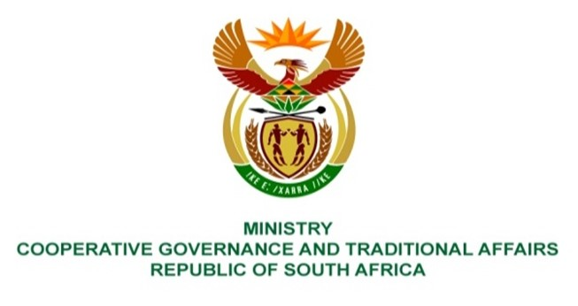

NATIONAL ASSEMBLY
QUESTIONS FOR WRITTEN REPLY

QUESTION NUMBER: PQ 647
DATE OF PUBLICATION: 4/3/2022

QUESTION:

647: Mr C Brink (DA) to ask the Minister of Cooperative Governance and Traditional Affairs:
Whether she has been informed of any contravention of sections 57A(1) and (3) of the Municipal Systems Act, Act 32 of 2000; if not, what is the position in this regard; if so, what (a) are the details of each contravention and (b) measures has she taken in response to each of the contraventions?
REPLY:

1. This register became a dormant as a result of the invalidation of the Amendment Act on 9 March 2019, therefore sections 57A(1) and (3) are no longer applicable.

(a) Not applicable.
(b) Not applicable.

