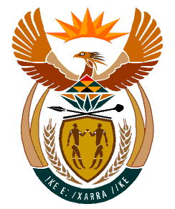

MINISTRY:
HUMAN SETTLEMENTS, WATER AND SANITATION
REPUBLIC OF SOUTH AFRICA

NATIONAL ASSEMBLY

QUESTION FOR WRITTEN REPLY

QUESTION NO.: 646

DATE OF PUBLICATION: 24 APRIL 2020

Mr R A Lees (DA) to ask the Minister of Human Settlements, Water and Sanitation:
With reference to her reply to question 34 on 13 March 2020, what are the details of (a) each of the estimated expenses that make up the preliminary cost estimate of R1 941 894 392,00, (b) the payments made by all government and municipal departments and entities to persons and/or consultants on the project since it was initiated up to 29 February 2020, and (c) work done on the project by all consultants since the project was initiated up to 29 February 2020 including but not exclusively by each consultant in terms of (i) name, (ii) profession, (iii) work done, (iv) the amounts paid to each and (v) the dates that the work done by each consultant was completed? NW848E

REPLY:
The estimated cost of R1 941 894 392 provided in my reply to question 34 was for the entire Driefontein Bulk Water Supply Scheme. The project in question (i.e. Ladysmith (Spioenkop) Bulk Water Supply Scheme) constitutes a third phase of the project. The breakdown is as follows:

 | Driefontein Bulk Complex – Phase 1 | Driefontein (Hobsland-Indaka) Bulk Water Scheme  – Phase 2 | Spioenkop-Ladysmith Bulk Water Supply Scheme  – Phase 3 | Total Cost
MIG Funding | 3,023,354 | 20,042,456 | 40,699,215 | 63,765,025
RBIG Funding | 116,739,394 | 281,002,717 | 479,397,225 | 877,139,336
Other Funding |  |  | 1,000,990,031 | 1,000,990,031
Total | 119,762,748 | 301,045,173 | 1,521,086,471 | 1,941,894,392

No payments have been made on the Spioenkop-Ladysmith Bulk Water Supply Scheme because the project is still in the feasibility study phase which Umgeni Water undertook to fund from its own coffers.

