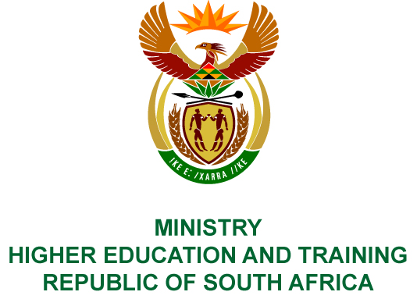
Private Bag X893, Pretoria, 0001, Tel (012) 312 5555, Fax (012) 323 5618
Private Bag X9192, Cape Town, 8000, Tel (021) 469 5150, Fax: (021) 465 7956
Memorandum from the Parliamentary Office
NATIONAL ASSEMBLY
FOR WRITTEN REPLY
QUESTION 646
DATE OF PUBLICATION OF INTERNAL QUESTION PAPER: 09/03/2018
(INTERNAL QUESTION PAPER NO 6 OF 2018)
Mr A P van der Westhuizen (DA) to ask the Minister of Higher Education and Training:
(a) What was the (i) brief and (ii) findings of the forensic investigation that was ordered by her predecessor into allegations of fraud and corruption involving recipients of financial aid from the National Students Financial Aid Scheme in the 2015-16 financial year, (b) what measures were put in place in order to ensure that funding provided is used prudently and correctly in response to the (i) findings of the forensic audit and/or (ii) allegations, (c) who undertook the forensic investigation, (d) what were the costs of the investigation and (e) what approach was followed by the investigation to ensure that all kinds of reported abuse was covered?
NW720E
REPLY:
- The Department of Higher Education and Training appointed Nexus Forensic Services on 23 September 2015 to conduct an investigation into allegations of fraud and corruption in the allocation of the National Student Financial Aid Scheme (NSFAS) at ten identified public universities, and Technical and Vocational Education and Training (TVET) colleges.
- Terms of Reference of the investigation:
To conduct a comprehensive audit for the 2012, 2013 and 2014 academic years to determine the extent of misrepresentation and fraud committed by students who qualified and have received financial aid, including parents and guardians, employees of universities; public TVET colleges, NSFAS and individuals who have manipulated financial aid processes to defraud NSFAS.
The audit must include:
- Applicants and family members/guardians who have knowingly provided false information on their applications for financial aid;
- Applicants who have intentionally misrepresented their family income by purposefully providing false information on the certification of affidavits in terms of Section 9 of the Justice of Peace and Commissioners of Oaths Act 16 of 1963 and Regulations under the Act;
- The validity of affidavits submitted and signed in terms of Sections 5, 6 and 7 of the Justice of Peace and Commissioners of Oaths Act 16 of 1963 and applicable Regulations;
- The allegations of persons who impersonate Commissioners of Oath in order to certify falsified documentation to defraud NSFAS for personal gain;
- Applicants who have purposefully altered documentation used in the validation of the financial aid application and approval process that resulted in the receipt of financial aid;
- Service providers who collude with students to defraud the NSFAS;
- Staff at financial aid offices at universities; TVET colleges and NSFAS who deliberately do not comply with NSFAS and donor guidelines on eligibility and academic criteria to defraud the NSFAS;
- Nepotism and conflict of interests in the allocation of NSFAS financial aid at financial aid offices at public universities and TVET colleges; and
- The identification of the shortcomings and weaknesses in the NSFAS loan and bursary system including the current NSFAS guidelines and rules applicable to universities and public TVET colleges, with clear recommendations to address fraud risks identified.
The investigation should be concluded within 12 months. The Department may decide to extend the investigation based on the extent of allegations of fraud and corruption at a particular institution.
- The final report of the investigation was submitted to the Department on
15 March 2018.
- (i)-(ii) The report is being analysed and measures based on the findings and recommendations will be considered.
- Nexus Forensic Services (Pty) Ltd
- R2 053 249.07
- The investigation was undertaken in phases. Phase 1 consisted of the analysis of data and supporting documentation aimed at identifying fraud risks across the ten selected institutions. The Phase 1 report was presented to the Minister of Higher Education and Training on 10 March 2016. During Phase 1, Nexus Forensic Services (NFS) identified specific cases of students (identity numbers) and institutions who had been “red flagged” for further investigation in Phase 2.

Phase 2 of the investigation involved the original data analyses from Phase 1 being verified and/or compared with the student application information and the institutions’ final year reports. The NFS provided their report on Phase 2 to the Minister of Higher Education and Training on 14 March 2017. The Phase 2 report pointed to possible irregularities in the allocation of funds to some students.
The NFS identified different categories of potential irregularities, with a number of discrepancies within each category. They recommended that where there were a large percentage of alleged irregularities, samples of these categories should be further investigated in order to determine the veracity of the findings on the data. The Minister agreed that the investigation be extended, and that this would constitute the third and final phase of the investigation. The final report, once received, should provide details of the scale of irregularities and advice on mechanisms to ensure that these are dealt with systemically.

