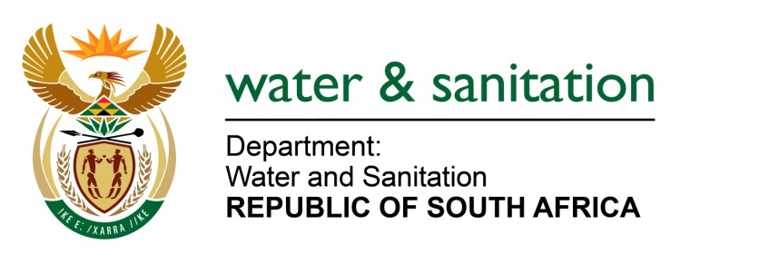

NATIONAL ASSEMBLY

FOR WRITTEN REPLY

QUESTION NO 646

DATE OF PUBLICATION IN INTERNAL QUESTION PAPER: 17 MARCH 2017
(INTERNAL QUESTION PAPER NO. 10)
646. Mr L J Basson (DA) to ask the Minister of Water and Sanitation:
(1) (a) What is the name of the contractor(s) to whom the contract(s) to raise the wall of the Clanwilliam Dam was awarded, (b) at what cost was the specified contract awarded, (c) on what date will the specified contractor(s) (i) commence and (ii) complete the relevant work and (d) how will her department’s personnel who are currently on the specified site be incorporated into the specified project;

(2) (a) what is the total cost of keeping her department’s personnel on the specified site and (b) what number of her personnel are currently employed on site? NW704E
---00O00---
REPLY:

(1) My Department is still in the process of evaluating and adjudicating the tender bids received for the construction of the raising of Clanwilliam Dam. Further details will only be known once a contractor has been appointed, after completion of the full procurement process.
(2)(a) Refer to the table below for the total cost incurred by Construction South for the month of February 2017 on the specified site is:
Cost element name | February 2017
Direct Labour | 1,218,300.34
Overheads | 647,548.65
Equipment: ChargeOut Rate | 129,441.17
Operating Lease: Land & Building (Accommodation) | 269,825.64
Municipality Service | 13,252.60
Water & Electricity | 24,683.16
S&T KM Claim | 31,557.74
Hire of Security Services | 175,270.49
Grand Total | 2,509,879.79

(2)(b) There is a total of 53 DWS: Construction South personnel, with 13 personnel on contract and 40 permanent employees.
---00O00---

