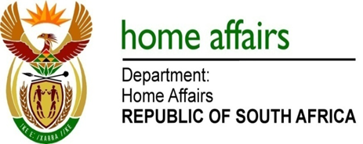

NATIONAL ASSEMBLY

QUESTION FOR WRITTEN REPLY

QUESTION NO. 644

DATE OF PUBLICATION: Friday, 17 March 2017

INTERNAL QUESTION PAPER 10 OF 2017

644. Mr K P Robertson (DA) to ask the Minister of Home Affairs:

With respect to children who are affected by the choices their parents make by illegally immigrating to South Africa, what are the rights of children or minors whose parents have moved to South Africa illegally to join the working class, in light of the fact that the specified children are now prevented from (a) writing matric, (b) opening bank accounts and (c) contributing to the economy? NW702E
REPLY:

Children of parents who are in South Africa illegally are expected to return to their home countries as a family unit either voluntarily or by deportation as per section 34(1) of the Immigration Act 13 of 2002. This section provides for the arrest and deportation of an illegal foreigner. The rights provided to the children would also be in line with the family unit by allowing for the right to appeal against the deportation or request the deportation to be confirmed by a warrant of a court. The detention of such a family would be at a place of safety pending their removal from South Africa.

