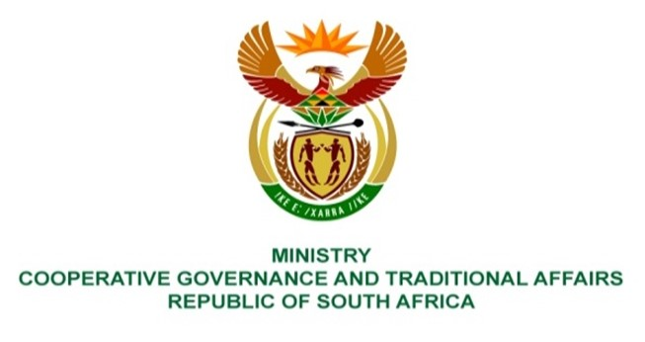

NATIONAL ASSEMBLY
QUESTIONS FOR WRITTEN REPLY

QUESTION NUMBER 642

642. Ms P Madokwe (EFF) to ask the Minister of Cooperative Governance and Traditional Affairs:

(1) Whether she has any power to take steps against a certain person (details furnished), whose voice recording has been circulating on social media wherein the person is alleged to have instructed senior staff to compromise supply chain management according to his wishes; if not, what is the position in this regard; if so, what are the powers that she has to make the person account for his actions;

(2) Whether she has directed that any investigations be undertaken in other municipalities to ensure that such abuse of power is not happening in other municipalities across the Republic; if not, why not; if so, what are the relevant details?

REPLY:

- No.Item 12(b) of the Local Government: Municipal Structures Act No. 117 of 1998, as amended, (“the Structures Act”) provides that a councillor may not, except as provided in law, give or purport to give any instruction to any employee of the council, except when authorised to do so. However, the authority to take appropriate steps for the implementation of the Code of Conduct for Councillors (“the Code”) lies with the speaker, or the municipal council, and the MEC responsible for local government in the province (“the MEC”), subject to the provisions of item 15 and 16 of the Code.

Item 15 of the Code provides that if the speaker is of the opinion that a provision of the Code has been breached, then the speaker must authorise an investigation of the facts and circumstances of the alleged breach, and thereafter report the matter to a meeting of the municipal council, and also report the outcome thereof to the MEC in the province. The MEC may furthermore, in terms of item 16 of the Code, suspend the councillor for a period as may be determined by the MEC, or remove the councillor from office.

Note that the specific instance also constitutes a breach of section 173 of the Municipal Finance Management Act No. 56 of 2003 and should be dealt with in terms of that Act read with the Municipal Regulations on Financial Misconduct and Criminal Proceedings.

- No. As indicated in response provided in paragraph (1) above, any investigations concerning an alleged breach of the Code, must be undertaken by the speaker, or the municipal council, or the MEC for local government in the province if considered necessary, subject to the provisions of items 15 and 16 of the Code.

End.

