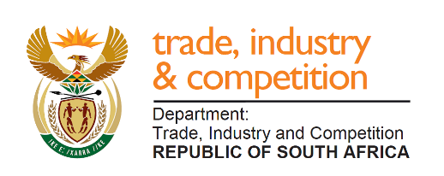

THE NATIONAL ASSEMBLY
QUESTION FOR WRITTEN REPLY
PARLIAMENTARY QUESTION 64

Mr D W Macpherson (DA) to ask the Minister of Trade and Industry:

With regard to the African Continental Free Trade Area, what budget has been allocated specifically for trade promotion in the medium term for South African manufacturers to take advantage of this agreement? NW68E

RESPONSE

I have requested the Department to prioritise trade with the rest of the Continent over the MTEF and accordingly, a growing part of the budget will be directed to trade promotion and the activities of the Development Finance Institutions will also be harnessed.

R80 million of the current export promotion budget supports intra-Africa trade and investments over the MTEF period, but, as indicated above, we will be drawing on a wider resource-envelope.

-END-

