36/1/4/1(201900009)
NATIONAL ASSEMBLY

FOR WRITTEN REPLY QUESTION 64
DATE OF PUBLICATION IN INTERNAL QUESTION PAPER: 7 FEBRUARY 2019 (INTERNAL QUESTION PAPER NO 1-2019)

64. Mrs E N Ntlangwini (EFF) to ask the Minister of Police:

- Whether he has been informed that he has been implicated in testimony made under oath and in written documents by Mr Agrizzi at the Judicial Commission of Inquiry to Inquire into Allegations of State Capture, Corruption and Fraud in the Public Sector including Organs of State, chaired by Deputy Chief Justice Raymond Zondo; if so, were the allegations made by Mr Agrizzi in respect of him true;

- whether he declared any financial or material gifts from Bosasa as required by the Executive Members’ Ethics Act, Act 82 of 1998; if not, what is the position in this regard; if so, what are the relevant details?
NW69E
REPLY:

(1) Yes, the Minister of Police, Honorable B.H Cele is aware of the testimony
given by Mr Agrizzi at the Judicial Commission of Inquiry to Inquire into Allegations of State Capture, Corruption and Fraud in the Public Sector including Organs of State, chaired by Deputy Chief Justice Raymond Zondo. In his capacity of the former Deputy Minister for Agriculture, Forestry and Fisheries, Honorable B.H Cele was invited by the former President of the Republic of South Africa, His Excellency G.J Zuma to go and view an Aqua Cultural project by two (2) brothers, which was later known to be the Bosasa CEO and his blood brother who manages the Aqua Cultural prawn farm in the Vaal.

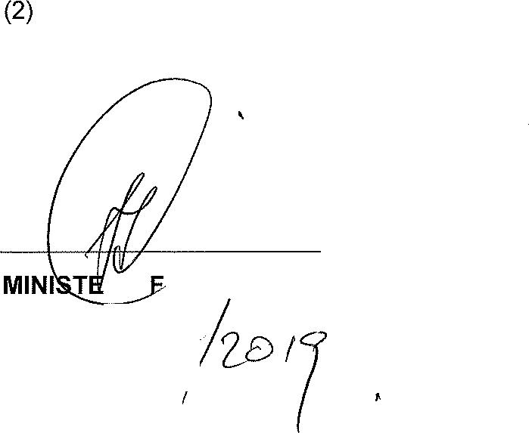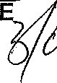No, there were no gifts either financial or material received from Bosasa by the former Deputy Minister of Agriculture, Forestry and Fisheries, Honorable
B.H Cele.

R O POLICE, MP
B.H CEL DATE:

