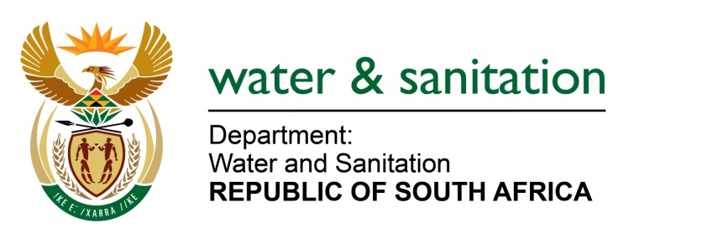

NATIONAL ASSEMBLY

FOR WRITTEN REPLY

QUESTION NO 637

DATE OF PUBLICATION IN INTERNAL QUESTION PAPER: 11 MARCH 2016
(INTERNAL QUESTION PAPER NO. 8)

637. Ms M S Khawula (EFF) to ask the Minister of Water and Sanitation:
Whether, with reference to the freshwater ecosystems that are in an endangered state (details furnished), she has engaged with the Minister of Environmental Affairs to collectively come up with a coherent programme for preserving our ecological infrastructure, such as wetlands and other freshwater ecosystems which are key for sustainable water supply; if not, why not; if so, what are the relevant details? NW750E
---00O00---
REPLY:
Yes, I have been engaging with the Minister of Environmental Affairs on different platforms to collectively come up with a coherent programme for preserving our ecological infrastructure. These engagements have resulted in several strategies and action plans, as follows:
- Chapter 5 of the National Water Resource Strategy 2, outlines the protection strategies for our fresh water ecosystems which are inclusive of rivers, and wetlands. The progress in the implementation of these protection measures is monitored in the outcome 10 report of the Minister of Environmental Affairs as a key performance indicator on the number of rivers that have been classified. A joint Implementation Plan with the Department of Environmental Affairs (DEA) has been developed to ensure the implementation of protection measures and the sustainable functioning of ecological infrastructure. It is important to note that this Implementation Plan is also in alignment with the National Biodiversity Strategy and Action Plan developed by the DEA.

- The Classification, determination of the Reserve and Resource Quality Objectives work done by my Department, takes into cognisance the information contained in the National Freshwater Ecosystem Priority Areas (NFEPA) and Strategic Water Source Areas developed by DEA, in collaboration with SANBI & the CSIR and stringent protection conditions are prescribed to protect ecologically important and sensitive ecological resources e.g. threatened wetland habitat, rivers, lakes, pans and estuaries which have been identified within these studies.

- These protection measures outlined above are further translated into license conditions when the different water use authorisation applications are approved with clear recommendations on the management of the ecological infrastructure. My Department and DEA have a joint responsibility in the management of estuaries, where my Department is responsible for determining the ecological state, importance and sensitivity of estuaries and DEA is responsible for the regulatory measures for maintaining the ecological state. The ecological information determined by my Department is taken into consideration by DEA when issuing of permits for the utilisation of estuaries.
---00O00---

