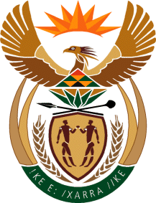

Ministry
Employment & Labour
Republic of South Africa
Private Bag X499, PRETORIA, 0001. Laboria House 215 Schoeman Street, PRETORA Tel: (012) 392 9620 Fax: 012 320 1942
Private Bag X9090, CAPE TOWN, 8000. 120 Plein Street, 12th Floor, CAPE TOWN Tel: (021) 466 7160 Fax 021 432 2830
www.labour.gov.za

NATIONAL ASSEMBLY

WRITTEN REPLY

QUESTION NUMBER: 636 [NW752E]

636. Ms C N Mkhonto (EFF) to ask the Minister of Employment and Labour:

Whether he has done any compliance assessment with the provisions of the National Minimum Wage Act, Act 9 of 2018, since it became effective; if not, why not; if so, what (a) sectors has he found are not complying with the national minimum wage and (b) steps has he taken to ensure that they comply? NW752E
REPLY:

The Department has compliance assessment to determine compliance with the provisions of the National Minimum Wage Act 9 of 2018. For the 2019/20 a total number of 134 964 inspections were conducted
- The following sectors were found not have complied with the provisions of the National Minimum Wage:
• Community
• Wholesale & Retail
• Hospitality
• Private Security
• Domestic
(b) Those not complying were issued with the statutory non-compliance notice (undertaking/compliance orders). Those that did not comply with the terms of the compliance notices were referred for prosecution, at the expiry of the notice.

