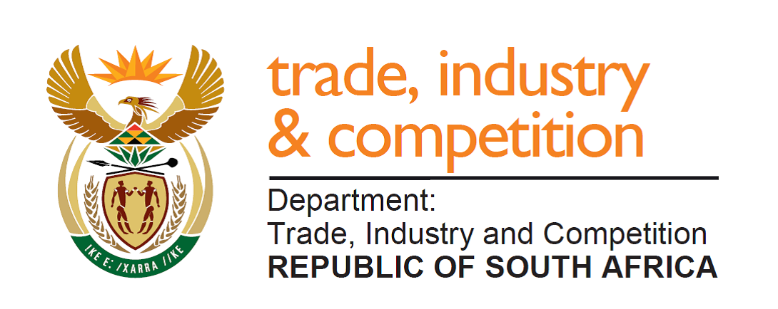

NATIONAL ASSEMBLY

WRITTEN REPLY

PARLIAMENTARY QUESTION 636

DATE OF PUBLICATION: 23 AUGUST 2019
Mrs Y N Yako (EFF) to ask the Minister of Trade and Industry:
(a) What is the status of the B-BBEE Commission investigation into the case number: 3/7/2017 between certain entities (details furnished), (b) on what date was the case first brought forward to the commission and (c) when will the (i) investigation be completed and (ii) findings released? NW1634E

Reply
The B-BBEE Commission has advised me that the complaint was lodged on 31 July 2017; that the Respondent in the matter requested that alternative dispute resolution processes be used, which was agreed to by the complainant and that this process has not resulted in an agreed outcome. The Commission issued its preliminary findings on 2 September 2019. The respondent has 30 days to respond and thereafter the B-BBEE Commission will issue its findings.

-END-

