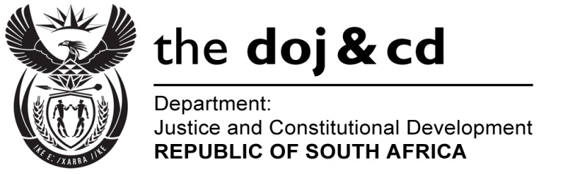
NATIONAL ASSEMBLY
QUESTION FOR WRITTEN REPLY
PARLIAMENTARY QUESTION NO: 636
DATE OF QUESTION: 17 MARCH 2017

DATE OF SUBMISSION: 03 APRIL 2017
Adv G Breytenbach (DA) to ask the Minister of Justice and Correctional Services:
What is the (a) make, (b) model, (c) price and (d) date on which each vehicle was purchased for the use of the National Director of Public Prosecutions, Mr Shaun Abrahams, since his appointment to the specified position on 18 June 2015?
NW694E

REPLY:

- Make: Mercedes Benz GLE 350d SUV
- Model: 2016
- Price: R1 234 157.97
- The vehicle was procured on 17 March 2016 via G Fleet as part of the RT57 Government Contract as approved by the Minister of Justice & Correctional Services on 27 January 2016.

