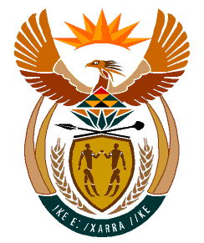

MINISTRY:
HUMAN SETTLEMENTS, WATER AND SANITATION
REPUBLIC OF SOUTH AFRICA

NATIONAL ASSEMBLY

QUESTION FOR WRITTEN REPLY

QUESTION NO.: 635

DATE OF PUBLICATION: 24 APRIL 2020

Mrs M R Mohlala (EFF) to ask the Minister of Human Settlements, Water and Sanitation:
Whether she will intervene to ensure that the borehole which was constructed in Nyanyukani in the Mopani District Municipality, which does not have electricity due to non-payment of electricity to Eskom, is reconnected; if not, why not; if so, what are the further relevant details? NW837E

REPLY:

Honourable Member, I have been informed that challenges relating to the borehole in Nyanyukani B have been resolved. This was confirmed after a site visit was undertaken by staff of the Department’s Regional Office in Limpopo on 11 May 2020 to the area.

The borehole in Nyanyukani B was initially connected to the community (household) electricity supply. ESKOM resolved that the borehole should have its connection where a transformer was to be installed. The Mopani District Municipality (DM) found the costs of installing transformers to all boreholes to be unaffordable and the borehole was legalized by Eskom without having a transformer.

In 2019 Eskom disconnected all boreholes in the Mopani District without transformers as they were considered to be illegally connected. The Mopani DM submitted a new electricity application for the borehole in 2019.

Upon consultation with the Mopani DM, the Department of Water and Sanitation was informed that the electricity supply to the borehole in Nyanyukani B had been restored and the borehole was back in operation.

