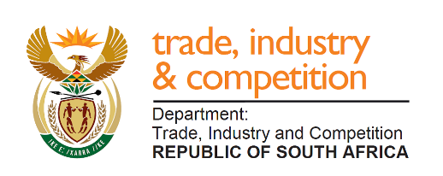

THE NATIONAL ASSEMBLY
QUESTION FOR WRITTEN REPLY
PARLIAMENTARY QUESTION 63

Mr D W Macpherson (DA) to ask the Minister of Trade and Industry:

Whether the National Lotteries Commission has received applications from the South African Sports Confederation and Olympic Committee in support of delivering TeamSA to the (a) 2020 Tokyo Olympic Games and (b) 2020 Tokyo Paralympic Games; if so, (i) what are the relevant details of the applications, (ii) why was funding not paid out and (iii) on what date is it envisaged that the funds will be paid out? NW67E

REPLY
I am advised by the NLC that according to their records, they have not received any application from the South African Sports Confederation and Olympic Committee (SASCOC) relating to the 2020 Tokyo Olympic & Paralympic Games.

Following a further request for information, they have provided me with additional details that note the following:
- Funding was provided to SASCOC for activities which in the opinion of the NLC is not related to the Tokyo Olympic Games, namely tracking of team qualifications, athlete tracking and monitoring and sports equipment and apparel.
- Funding was provided to the organisation Special Olympics South Africa for “Tokyo 2020 Olympics and Paralympics Prospect Medallists, Olympic & Paralympic Athletes and Coaches Support”.

-END-

