**_______________________________________**

**NATIONAL ASSEMBLY**

**QUESTION FOR WRITTEN REPLY**

**QUESTION NUMBER: 627**

**DATE OF PUBLICATION IN INTERNAL QUESTION PAPER: 24 APRIL 2020**

**INTERNAL QUESTION PAPER NUMBER: 12 - 2020**

**627. Mrs D B Ngwenya (EFF) to ask the Minister of Social Development:**

Whether the Gender-Based Violence Command Centre has compiled statistics on gender-based violence; if not, why not; if so, what number of (a) calls has the centre received and (b) these calls were reported to the SA Police Service? NW827E

**National Assembly written Reply: 627 of 2020**

**REPLY:**

1. Yes, the Gender Based Violence Command Centre compiles/records statistics. See below records of calls, USSDs as well as SMSs recorded:

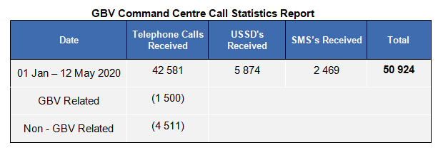

(b)

All Gender Based Violence emergency calls are referred to SA Police Service. However, not all received calls are reported or referred to SA Police Service. It is dependent on the merit of case as well as the present issue of the client. The Gender Based Violence Command Centre is equipped with Social Work Practitioners who provides immediate psychosocial social support services including emotional support through trauma counselling and victim containment.