(INTERNAL QUESTION PAPER NO 2-2019)

NATIONAL ASSEMBLY

36/1/4/1(2019)

FOR WRITTEN REPLY QUESTION 623
DATE OF PUBLICATION IN INTERNAL QUESTION PAPER: 15 FEBRUARY 2019 (INTERNAL QUESTION PAPER NO 623)

623. Ms D Carter (Cope) to ask the Minister of Police:
In line with the Independent Police Investigative Directorate Act, Act 1 of 2011, what are the details of the skills, qualifications and experience that he took into account in his decision to appoint Mr Victor Senna as the Acting Director of the Independent Police Investigative Directorate? NW746E

Answer

In terms of provisions of section 6 (4) and (5) of Independent Police Investigative Directorate Act 1 of 2011, the Minister May designate another person to act as Executive Director when the Executive Director is unable to perform his/her functions or when the vacancy exist. In appointing the Acting Executive Director the Minister has taken into account his seniority in the IPID, his qualifications and experience.
Below is the profile of Mr Victor Senna.

PROFILE FOR Mfl VIC TOfI OFENTSE SENNA

1. EDUCATIONAL QUALIFICATIONS

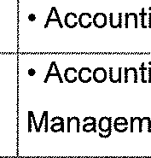
,. .. ..... .. ....

QUALIFICATIONS
“Senior”Certificate
- B.com

  - Marketing, Sales Management
- National Higher Certificate
- Masters In Public ”““
Administration and Management (MPA)
- B. Com Honours (Financial
Management)
“• Public Administration and Management, Public “ Policy development, Public sector financial management, Human resource management, Project Management.
  - Supply Chain Management ””” “
  - Project Management
  - Financial Management
  - Strategic Management
  - Investment Management

3. OTHER FORMAL COURSES ATTENDED

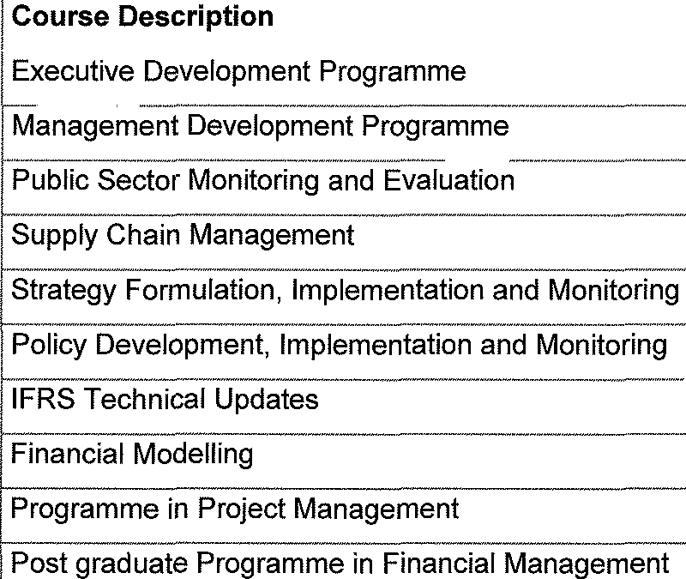

5. SUMMARY OF EXPERIENCE

Employer
Gauteng Department of Health
(GDOH)
Chief Director: Budget
management and Revenue
2 years
South Afrcan Social
”
””
Security Agency (SASSA), Western
Cape Regional Office Department of Scence and” ”””
Technology
General Manager/ Regional 2 years
CFO: Western Cape
Director: Financal
” ”
””””
Management (Sector Budget
Support Programme)
Act. Chief Director: Sector
Budget Support Programme

M
Kind re ds,
in
f Police
BH Cele ) Date:

