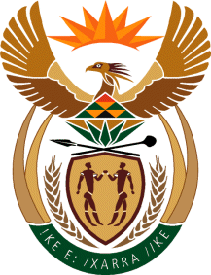
MINISTRY: SPORT AND RECREATION
REPUBLIC OF SOUTH AFRICA

Private Bag X869, Pretoria, 0001, Tel: (012) 304 5158, Fax: (012) 323 8426
Private Bag X9149, Cape Town, 8000, Tel: (021) 465 5506/7/8/9, Fax: (021) 465 4402
_____________________________________________________________________

NATIONAL ASSEMBLY

WRITTEN REPLY

622. Mr. T. W. Mhlongo (DA) asked the Minister of Sport and Recreation:
(1) What position does a certain person (name furnished) currently hold in his department;
(2) Whether he has taken any action against the specified person for alleged racism; if not, why not; if so, what are the relevant details?
NW680E
______________________________________________________________________
The Minister of Sport and Recreation
REPLY:

The individual in question is no longer with the Department of Sport and Recreation South Africa.

