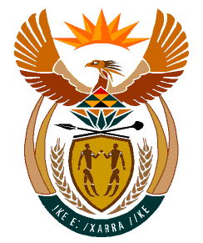

MINISTRY:
HUMAN SETTLEMENTS, WATER AND SANITATION
REPUBLIC OF SOUTH AFRICA

NATIONAL ASSEMBLY

QUESTION FOR WRITTEN REPLY

QUESTION NO.: 621

DATE OF PUBLICATION: 24 APRIL 2020

Ms R N Komane (EFF) to ask the Minister of Human Settlements, Water and Sanitation:
Whether her department is putting measures in place to deliver water to Ward 20 in Ga-Mohlala in the Makhuduthamaga Local Municipality in order to provide the ward with a regular water supply? NW821E

REPLY:
Ga-Mohlala is a village with a population of five thousand eight hundred and twenty five (5825) and one thousand three hundred and fifty four (1354) households. The village water supply depends on eight boreholes; with five boreholes which are part of a project that was implemented in 2016 as part of the Municipal Infrastructure Grant (MIG) intervention which unfortunately was not successful. There are also three hand pumps which are not functional. Two of the hand pumps were vandalized and need to be re-drilled whilst one can be fixed.

The municipality met with the complainants on 06 May 2020 for a site inspection as part of finding a solution to the ongoing water challenges. It was agreed that the municipality will send a maintenance team to fix the hand pump that was not vandalized, as part of the short term intervention.

As part of the medium-term solution, the municipality will further intervene and refurbish the five boreholes which were part of the previous unsuccessful project so as to ensure there is water for the people of Ga-Mohlala.

The Department of Water and Sanitation has also provided 5 water tanks (2 x 10000 and 3 x 5250 litres) and 1 tanker to the Makhuduthamaga Local Municipality as part of its COVID-19 interventions to ensure access to clean water.

