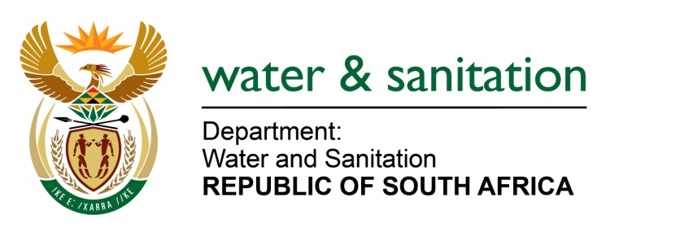

MINISTER OF WATER AND SANITATION

FOR WRITTEN REPLY

QUESTION NO 620

DATE OF PUBLICATION IN INTERNAL QUESTION PAPER: 4 MARCH 2022
(INTERNAL QUESTION PAPER NO. 6)

620. Mrs M R Mohlala (EFF) to ask the Minister of Water and Sanitation:

What is the reason that residents in Sekhukhune in Limpopo do not have access to clean water, in spite of living near De Hoop Dam?

NW753E
---00O00---

MINISTER OF WATER AND SANITATION

The De Hoop Dam, including the first section (40km) of the primary bulk pipeline to Steelpoort (ORWRDP Phase 2C) was completed in 2014. The construction of a secondary bulk to distribute water to the villages within the Nebo Plateau from De Hoop dam from the Malekana Water Treatment Works (WTW) commenced in January 2009.
The implementation of Nebo Scheme was planned in a phased approach and the first phase of the project was completed in December 2011. It was however, not commissioned due to delayed completion of the De Hoop Dam.
The commissioning of the completed Jane Furse pipeline from Malekana WTW to Jane Furse was also delayed due to deteriorated components of the pipeline and pump stations. The commissioning of the pipeline was halted because the contractor experienced cash flow challenges and the company was placed under business rescue.
The scheme has a capacity of 12 Ml/d and has been partially commissioned. It is operating at 4Ml/d through the Malekana WTW as construction for most of the bulk infrastructure is still in progress. The plant provides water to eight villages including Ga-Malekana, Ga-Masha, Ga-Maepa, Makakateng, Mphana, Mpelegane, Ga-Maphopha and Ga-Rantho. The Sekhukhune District Municipality (DM) is in the process to resume the commissioning process to functionalise the pipeline from Malekana to Jane Furse, which will supply water to forty-two (42) more villages.
Once the construction of the bulk water supply infrastructure pipelines is completed, the capacity of the Malekana WTW will ensure the sustainable water provision to all the villages that are meant to benefit from the scheme.
To cater for growing demand for water in the area, the Sekhukhune DM has concluded the technical report to upgrade the WTW from 12Ml/d to 24Ml/d. However, the funding remains a challenge as the Municipal Infrastructure Grant is fully committed. There is a need to reprioritise funding for the WTW upgrade as soon as possible to align with bulk distribution projects. The funding required amounts to R121 million.
---00O00---

