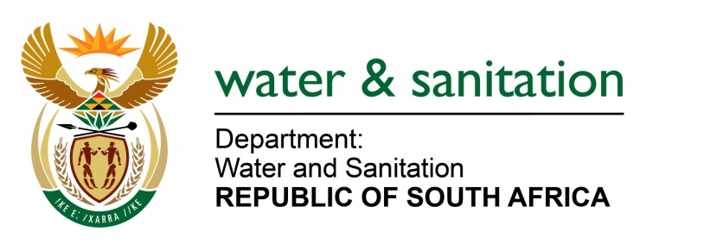

MINISTER OF WATER AND SANITATION

FOR WRITTEN REPLY

QUESTION NO 619

DATE OF PUBLICATION IN INTERNAL QUESTION PAPER: 4 MARCH 2022
(INTERNAL QUESTION PAPER NO. 6)

619. Mrs M R Mohlala (EFF) to ask the Minister of Water and Sanitation:

What is the reason that there is no water for residents in Giyani in Limpopo, despite the R3 billion that his department spent on the water project?

NW752E
---00O00---

MINISTER OF WATER AND SANITATION

The Department initiated the Giyani Water Services intervention in August 2014 with the intention to address water services challenges experienced by the communities in Giyani. The project was initiated as a Ministerial directive to Lepelle Northern Water (LNW) for immediate intervention in Mopani District to address water challenges. LNW conducted assessment of water services infrastructure in Giyani and initiated the following interventions:
- Refurbishment of existing water and sanitation infrastructure, including pump stations, repairs of leaking pipes and reservoirs, borehole development and installation of package plant for immediate supply to social facilities (Nkhensani Hospital).
- Construction of 1.5 Ml/d Wastewater Treatment Works (WWTW) to augment existing Giyani WWTW.
- Revitalization of 154 boreholes to augment water supply in 55 villages around Giyani.
- Replacement of inefficient bulk pipelines that supply water to 55 villages around Giyani (about 325 km of pipeline).

The first two interventions above were completed by the service provider appointed by LNW as the Implementing Agent (IA).

The service provider was meant to refurbish 154 boreholes. However, the functionality of most was impaired due to vandalism, theft, and incomplete installations. In addition, the contract of the professional service providers was terminated in December 2018 due to contractual disputes before the project could be concluded.

A recent assessment of the DWS on the boreholes indicates that 56% (86 of the 154) of the boreholes are operational, although some are limited due to issues such as water quality, non-connection to reticulation and operation and maintenance issues that should be addressed by the Mopani District Municipality. The majority (99%) of the installed package plants which contributed significantly to the expenditure, are not operational due to vandalism, theft and operations and maintenance challenges.

The intervention also included the replacement of unreliable pipelines that distribute water from Nsami Water Treatment Works (WTW) to 55 villages in Giyani. The last phase of the project connects service reservoirs in the villages and reticulate water to households. The overall construction progress on the pipelines is 51% and connections to the service reservoirs in 13 villages is completed. Benefiting areas include Giyani town, Khakhala, Thomo and Mahlathi villages.

In some villages, including Nwakhuwani, Homu 14B, Mapayeni and Hlomela the bulk pipeline has been completed, but the municipal infrastructure (reservoirs and reticulations) is not in a state to receive water or does not exist. The Mopani District Municipality is expected to ensure that the service reservoirs and reticulation infrastructure in all the villages are developed to distribute water to households.

The department is supporting the municipality through Water Services Infrastructure Grant (WSIG) to develop water service reservoirs and reticulation infrastructure to distribute water to communities. The municipality should also reprioritise funding to expedite development of receiving infrastructure in Giyani to align with the completion of bulk water pipeline project which is anticipated to be completed by December 2022.

The Nsami WTW is currently operating at the maximum capacity of 30Ml/d to supply the villages through the new and old bulk pipelines. The Mopani District Municipality had upgraded the WTW with additional 6,7Ml/d module which operated briefly but it was subsequently decommissioned due to structural defects in 2014. The Mopani DM should rectify the additional module urgently to augment the water supply from the water treatment works to the villages.

Implementation of water conservation and demand management by the Mopani DM should be prioritised as there are a lot of illegal connections, leaks and water wastage that renders the reticulation inefficient to supply all households in areas where infrastructure is in place.

