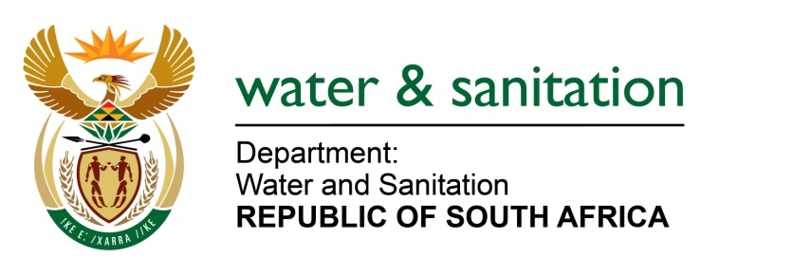

MINISTER OF WATER AND SANITATION

FOR WRITTEN REPLY

QUESTION NO 618

DATE OF PUBLICATION IN INTERNAL QUESTION PAPER: 4 MARCH 2022
(INTERNAL QUESTION PAPER NO. 6)

618. Mrs M R Mohlala (EFF) to ask the Minister of Water and Sanitation:

With reference to the financial component of the establishment of the National Water Resources Infrastructure Agency (NWRIA), how will (a) the Presidential Infrastructure Fund and (b) loans from the Development Bank of Southern Africa complement the work of the NWRIA?

NW751E
---00O00---

MINISTER OF WATER AND SANITATION

South Africa requires an ongoing and sustained multiple water resource infrastructure build programme, in addition to effectively operating and maintained existing assets. However, due to fiscal constraints, DWS cannot only rely on fiscal support to develop the required infrastructure especially for the implementation of the National Water and Sanitation Master Plan.

The National Water Resources Infrastructure Agency (NWRIA) would be better positioned than the Department of Water and Sanitation to raise funds from sources other than the fiscus and be able to seek lines of credit with international multilateral institutions. These will include commercial banks and development finance institutions such as the Development Bank of Southern Africa (DBSA).
The NWRIA will consider a hybrid model when it comes to infrastructure funding, which will also include the Presidential Infrastructure Fund. Based on its PFMA listing and authority, credit rating and condition of assets, the NWRIA would be able to raise commercial and development finance, domestic and international markets. The DWS will continue engagements with the Infrastructure Fund with the aim of identifying projects that could be financed through the Fund.

