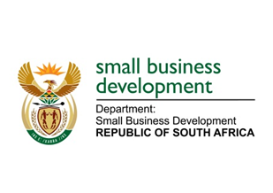
NATIONAL ASSEMBLY
QUESTION FOR WRITTEN REPLY
DUE DATE: FRIDAY, 19 MARCH 2021

“617. Ms B Mathulelwa (EFF) to ask the Minister of Small Business Development:
Whether her department considers the taxi industry as part of small businesses that need government assistance; if not, what is the position in this regard; if so, what steps has she taken to make it easy for aspirant taxi business owners to enter and grow in that form of business?” NW733E

REPLY:
The taxi industry is part of the small business sector. The industry is not only critical as a provider of transport but it also enables other small businesses throughout its value chain, for example informal traders, motor mechanics, panel beaters, auto spares and fitment centres. In 2019, the Minister interacted with the leadership of SANTACO on mechanisms to support the industry and the Department of Small Business Development (DSBD) also supported the Department of Transport towards the Taxi Indaba.

Given the mandate and programmes of the Department of Transport, the DSBD can only play a supporting role to those programmes agreed at the Taxi Indaba to avoid duplication of efforts by government. However, the DSBD is implementing programmes to support businesses in the taxi industry value chain to be geared to support a modernised taxi industry such as the Motor mechanics, panel beaters, auto spares and fitment centres.
______________________________________________________________________________
RESPONSE RECOMMENDED BY:

_______________________
MR LINDOKUHLE MKHUMANE
ACTING DIRECTOR GENERAL: DEPARTMENT OF SMALL BUSINESS DEVELOPMENT
DATE:
______________________________________________________________________________
RESPONSE RECOMMENDED BY:

________________________
MS ROSEMARY CAPA, MP
DEPUTY MINISTER OF SMALL BUSINESS DEVELOPMENT
DATE:

_______________________________________________________________________________
RESPONSE APPROVED BY:

_________________________
MS KHUMBUDZO NTSHAVHENI, MP
MINISTER OF SMALL BUSINESS DEVELOPMENT
DATE:

