MINISTRY OF MINERAL RESOURCES REPUBLIC OF SOUTH AFRICA

PRIVATE BAG x 59, PRETORIA, 0001, Tel (012) 444 3979, Fax (012) 444 3145
PRIVATE BAG x 9111, CAPE TOWN, 8000 (021) 462 2310, Fax (021) 461 0859
Enquiries: Carmichael Ngalo G› Carmichael.ngalowdmr.gov.za

Memorandum: Parliamentary Liaison Office

NATIONAL ASSEMBLY QUESTION FOR WRITTEN REPLY

QUESTION NUMBER: 677 ADVANCE NOTICE No: NW1719E

DATE OF PUBLICATION IN INTERNAL QUESTION PAPER: Sept 2019 INTERNAL QUESTION PAPER NUMBER: 12
677. Mr K J Mileham (DA) to ask the Minister of Mineral Resources and Energy:

- Whether any license has been issued for mining, prospecting or exploration purposes to any mining company within 10 kilometers of the border of the Kruger National Park; if so, in each case, what are the details of each license issued, including the (a) date of issue, (b) company issued to, (c) minerals sought, (d) location of the license, (e) conditions attached to issuing of the license and (I) current status of each operation;

- whether the Department of Environmental Affairs, Forestry and Fisheries was consulted at any point during the licensing process; if not, why not; if so, what are the details of the input of the specified department on the licensing of the operations;

- whether environmental impact assessments were conducted; if not, in each case, why not; if so, (a) what did each environmental impact assessment recommend and (b) were these recommendations complied with before issuing licenses? Nwl7l9E

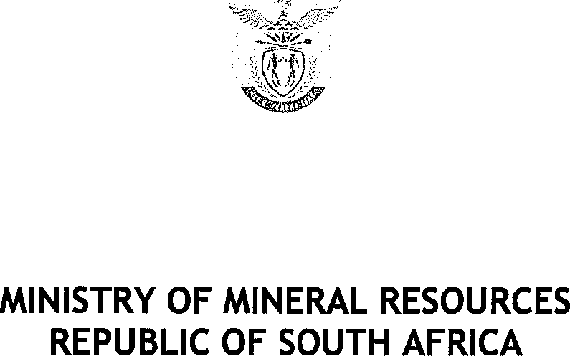

Reply

Yes, the Department has issued a prospecting right within 10 km of the border of the Kruger National Park.

(a) date of issue of the right: 06 October 2009 expiring on the 5 h October 2014, The said right was renewed and expired on the 26* August 2018.

- Name of the company: Manzolwandle Investments (Pty) Limited

- Minerals: Coal

- Location of the license: The Farm Tenbosch 162 JU, Turnbult 593 JU & Tecklenburg Ranch 548 JU in the Magisterial District of Barberton

- Conditions attached to the license: The applicable conditions of the prospecting right required the right holder to comply with section 19(1) and (2), section 38, 41, 42, 43 and the related Regulations as well as comply with the approved Environmental Management Plan (EMP)

§ Current status of the operation: The prospecting right has lapsed

- Yes, the following organs of state in charge with the environment in terms of section 40 of the MPRDA:

  - National Department of Water Affairs and Forestry
  - Department of Agriculture
  - Mpumalanga Department of Agriculture, Conservation and Environment
  - Mpumalanga Tourism & Parks Agency

- Yes, the Environmental Impact Assessment were conducted by the applicant as required in terms of section 39 of the MPRDA

- the EIA recommended that the right be issued and financial provision for rehabilitation paid by the applicant in terms of section 41 of the MPRDA.

- Yes, the applicant did comply with the recommendations.

